|  |
| --- |
| **Human Machine Interface**  **User Manual**    Version V648 |

**Table of Contents**

1. Main Interface 1

2. Module Selection 2

2.1 Module Number Setting 2

2.2 Module Address Setting 2

3. Module Parameter Setting 4

3.1 System Mode Setting 4

3.2 External CT Position Selection 4

3.3 Internal CT Position Selection 5

3.4 CT Ratio Setting 6

3.5 Priority Mode Selection 7

3.6 Reactive Compensation Function 7

3.7 Harmonic Compensation Function 8

3.8 Imbalanced Compensation Function 9

3.9 Target Power Factor Setting 10

3.10 Compensation Capacity Setting 10

3.11 Start-up Mode Setting 11

3.12 Phase Sequence Self-adaption Setting 12

3.13 Modifier 13

3.14 Save Para Button 14

3.15 Harmonic generator 14

4. Event Log 16

5. Description of Typical Application Parameter Setting 17

5.1 Mode Selection and CT Setting 17

5.2 Module Compensation Capacity Setting 17

# Main Interface

This manual mainly introduces the functional components of the user interface and the user operation information. The user can make the related operation through touching the display panel.

The boot main interface is shown in Figure 1-1.Display the real-time data of the module running, including power data, load data and module data.

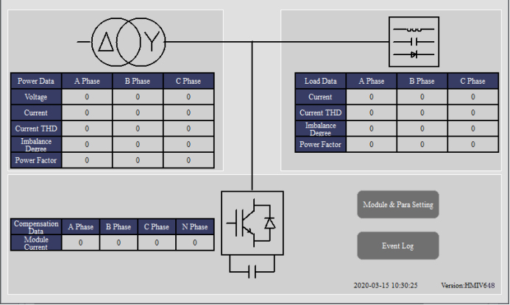

Figure 1-1 Boot Main Interface

The user can click the "Module & Para Setting" button to set module parameters and view data.

The user can click the "Event Log" button to view the various modules of on-off events and fault record.

# Module Selection

Click the "Module & Para Setting" button, enter the parameter setting interface.

## 2.1 Module Number Setting

Click the "Module Setting" option, set the number of modules in the "Module Number" option box, the user can set the most six modules, as shown in Figure 2-1.

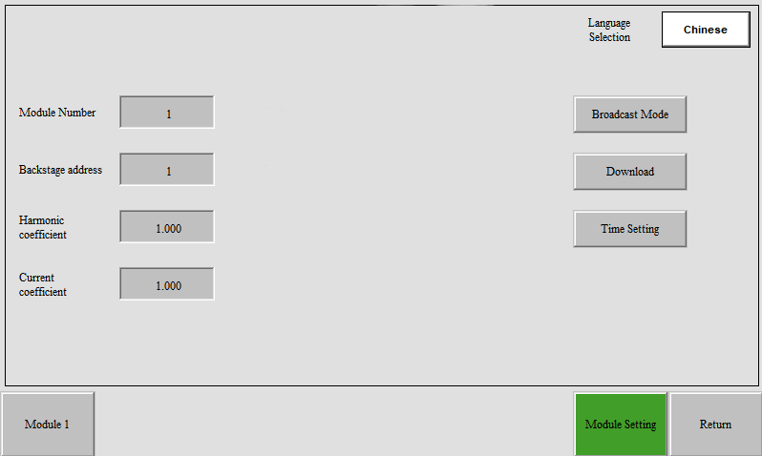

Figure 2-1 Module Setting

## 2.2 Module Address Setting

The module interface are one-to-one correspondence with the module address. For example, the interface of module 1 corresponds to the module data of address 1, the interface of module 2 corresponds to the module data of address 2, and so on.

Click the "Module 1" option, the user can set all the running parameters of the module 1 and view all the data of the module 1, as shown in Figure 2-2.

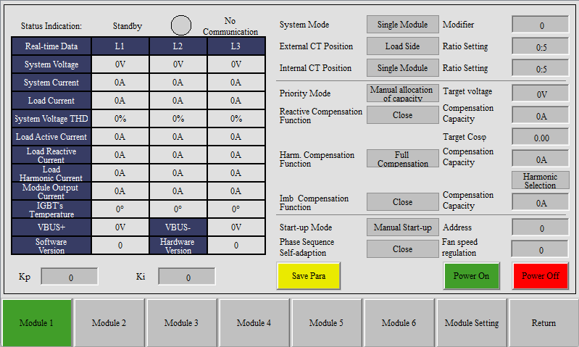

Figure 2-2 Module 1 Interface

Click the "Module 2" option, the user can set all the running parameters of the module 1 and view all the data of the module 2, as shown in Figure 2-3.

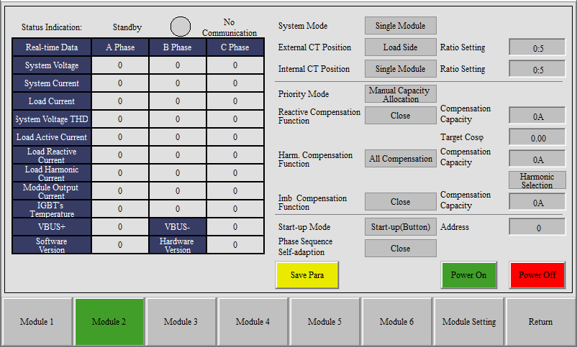

Figure 2-3 Module 2 Interface

# Module Parameter Setting

## 3.1 System Mode Setting

Click on Figure 2-2 "System Mode" option box, the Figure 3-1 will pop up.

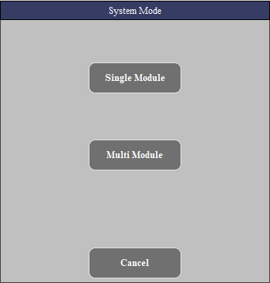

Figure 3-1 System Mode

System mode is divided into single module and multiple module mode. When more than two modules are connected in parallel, multiple module mode is adopted.

## 3.2 External CT Position Selection

Click on Figure 2-2 "External CT Position" option box, the Figure 3-2 will pop up.

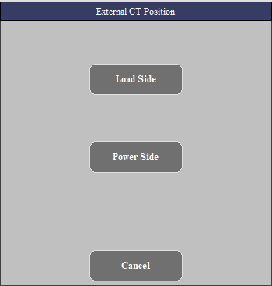

Figure 3-2 External CT Position Selection

The external CT position has two options: load side and power side, which are selected according to the actual installation position of the external CT.

|  |  |
| --- | --- |
| Load Side | External CT is installed on the right side of the module bus access point, close to the load. |
| Power Side | External CT is installed on the left side of the module bus access point, close to the transformer. |

## 3.3 Internal CT Position Selection

Click on Figure 2-2 "Internal CT Position" option box, the Figure 3-3 will pop up.

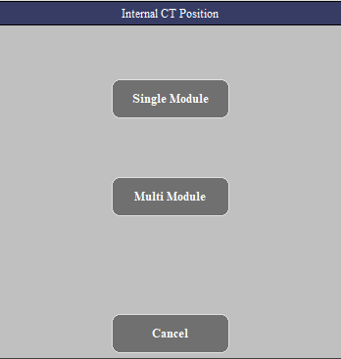

Figure 3-3 Internal CT Position Selection

The internal CT position is divided into single module and multiple module mode. When more than two modules are connected in parallel, multiple module mode is adopted.

## 3.4 CT Ratio Setting

Click on Figure 2-2 "Ratio Setting" option box, the Figure 3-4 will pop up. CT variable ratio parameters range from 50:5 to 20000:5. When setting CT variable ratio parameters, if it is necessary to set 1200:5, directly enter "1200" and confirm.

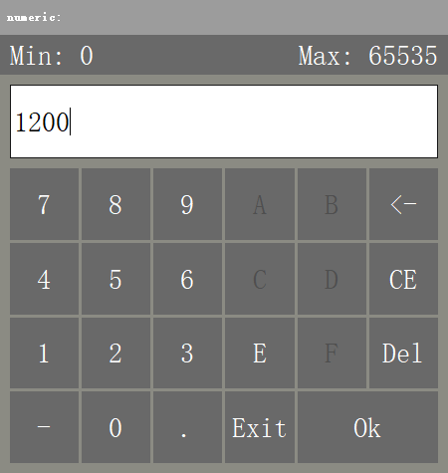

Figure 3-4 CT Ratio Setting

The variable ratio of external CT and internal CT shall be set according to the transformer ratio, the number of modules and the rated capacity of modules. Modules with different capacities in parallel shall be set according to the rated capacity of the module.

For example, if the external CT variable ratio is 2000:5, the internal CT variable ratio is 800:5, and the number of parallel modules with the same capacity is 4, then the external CT variable ratio parameter of each module is 500:5, and the internal CT variable ratio parameter is 200:5.

## 3.5 Priority Mode Selection

Click on Figure 2-2 "Priority Mode" option box, the Figure 3-5 will pop up.

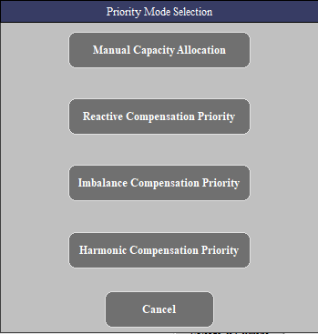

Figure 3-5 Priority Mode Selection

By default, the module is manual capacity allocation mode. In the mode of manual capacity allocation mode, the module compensates according to the capacity settings of each function compensation.

In the other three priority modes, the compensation capacity of all functions of the module should be set to the rated capacity. The module will compensate the specified items in priority. If there is any remaining capacity of the device after the compensation, it will be equally distributed to other items for compensation.

## 3.6 Reactive Compensation Function

Click on Figure 2-2 "Reactive Compensation Function" option box, the Figure 3-6 will pop up. Set the opening and closing of reactive compensation function.

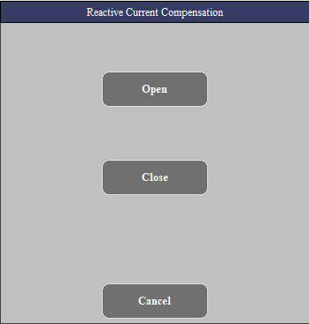

Figure 3-6 Reactive Compensation Function

## 3.7 Harmonic Compensation Function

Click on Figure 2-2 "Harm. Compensation Function" option box, the Figure 3-7 will pop up.

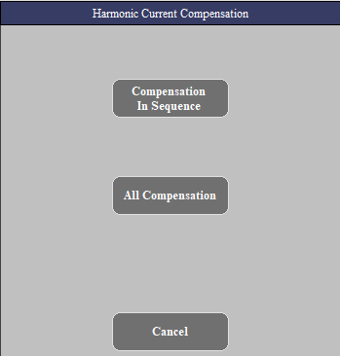

Figure 3-7 Harmonic Compensation Function

The harmonic compensation mode includes compensation in sequence mode and all compensation mode.

|  |  |
| --- | --- |
| compensation in sequence | The module compensates only the selected odd harmonic current. |
| all compensation | The module compensates all odd harmonic currents within 50 times. |

Click on Figure 2-2 "Harmonic Selection" button, the Figure 3-8 will pop up. The user can choose the harmonic compensation times.

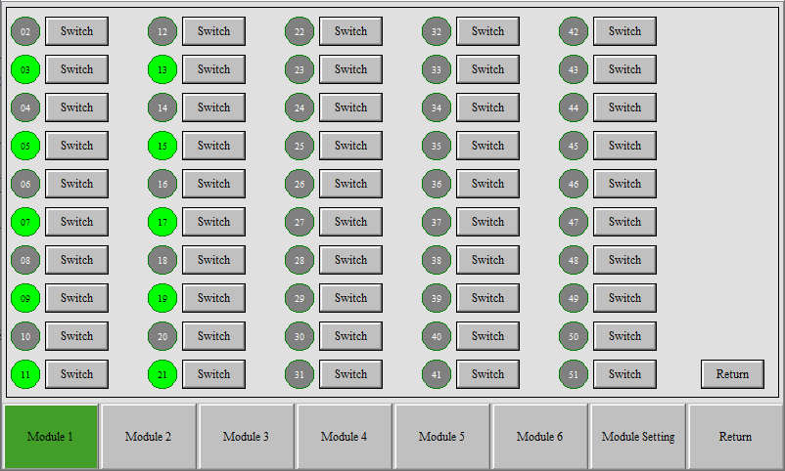

Figure 3-8 Harmonic Selection

## 3.8 Imbalanced Compensation Function

Click on Figure 2-2 "Imb Compensation Function" option box, the Figure 3-9 will pop up. Set the opening and closing of imbalanced compensation function.

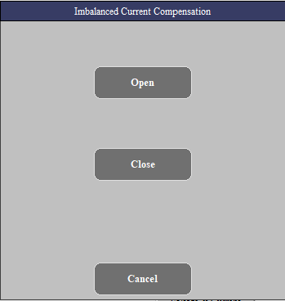

Figure 3-9 Imbalanced Compensation Function

## 3.9 Target Power Factor Setting

Click on Figure 2-2 "Target Cosφ" option box, the Figure 3-10 will pop up. Click to enter the target power factor.

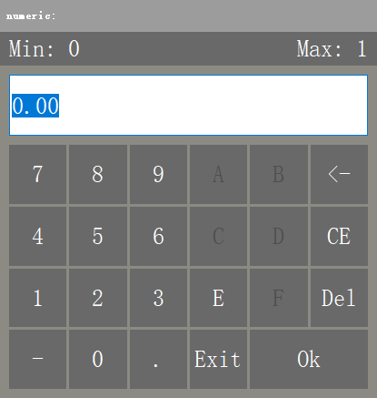

Figure 3-10 Target Power Factor Setting

## 3.10 Compensation Capacity Setting

Click on Figure 2-2 "Compensation Capacity" option box, the Figure 3-11 will pop up.

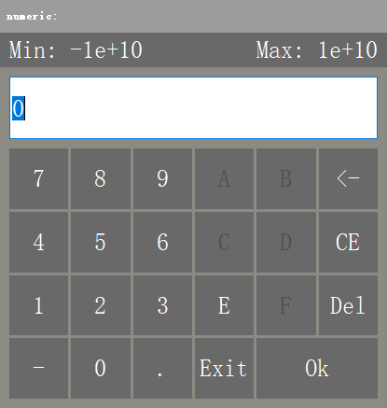

Figure 3-11 Compensation Capacity Setting

Description of compensation capacity parameter setting:

|  |  |  |  |
| --- | --- | --- | --- |
| Reactive Compensation Capacity | Harmonic Compensation Capacity | Imbalanced Compensation Capacity | Module rated capacity |
| X | Y*1.4 | Z | P=X+Y+Z （A:安培） |
| Instructions | 1. The compensation capacity of each function should be set according to the actual demand, in units of A (ampere) (1kvar= 1.5A). 2. The reactive compensation capacity (X), harmonic compensation capacity (Y) and imbalanced compensation capacity (Z) of all parallel modules must be consistent. 3. When the harmonic compensation capacity is setted, the coefficient of 1.4 shall be multiplied. | | |

## 3.11 Start-up Mode Setting

Click on Figure 2-2 "Start-up Mode" option box, the Figure 3-12 will pop up.

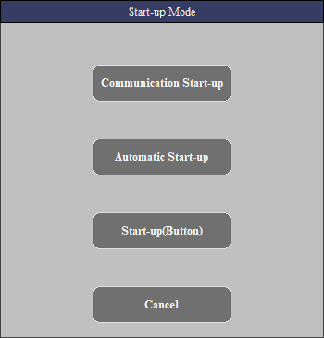

Figure 3-12 Start-up Mode Setting

The module has three modes of communication start-up, automatic start-up and button start-up.

|  |  |
| --- | --- |
| Start-up Mode | Instructions |
| Automatic Start-up | In this mode, the device is powered up automatically and can be shut down through the cabinet button or the LCD screen. |
| Button Start-up | In this mode, the device cannot be started automatically when it is powered on. It can be turned on or off through the cabinet button or the LCD screen. |
| Communication Start-up | In this mode, the device cannot be started automatically when it is powered on. It can be turned on or off through the cabinet button or the LCD screen (the function is exactly the same as that of the button start-up). |

## 3.12 Phase Sequence Self-adaption Setting

Click on Figure 2-2 "Phase Sequence Self-adaption" option box, the Figure 3-13 will pop up. Select on or off as needed.

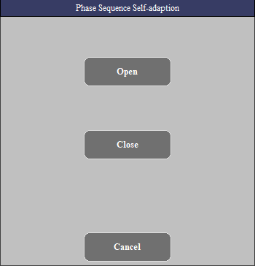

Figure 3-13 Phase Sequence Self-adaption Setting

## 3.13 Modifier

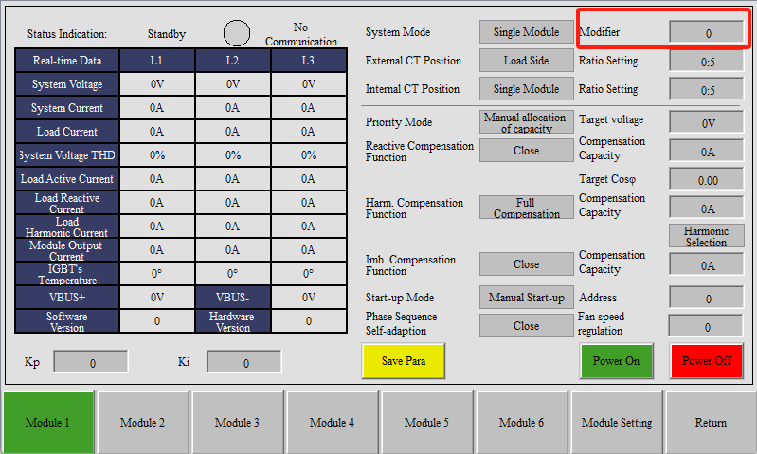

Modifier=Actual output current of the module - fully compensated output current of the module.   
For example, if the load reactive current is 50A (positive is inductive) and the modifier is set to 0, the module output current is 50A.   
If the modifier is set to 5 (positive is inductive), the module output current is 45A. If the modifier is set to -5 (negative is capacitive), the module output current is 55A

## 3.14 Save Para Button

When the module parameter setting is completed, click on Figure 2-2 "Save Para" button, then the module will have a restart process, which can be judged by the operation of the fan.

## 3.15 Harmonic generator

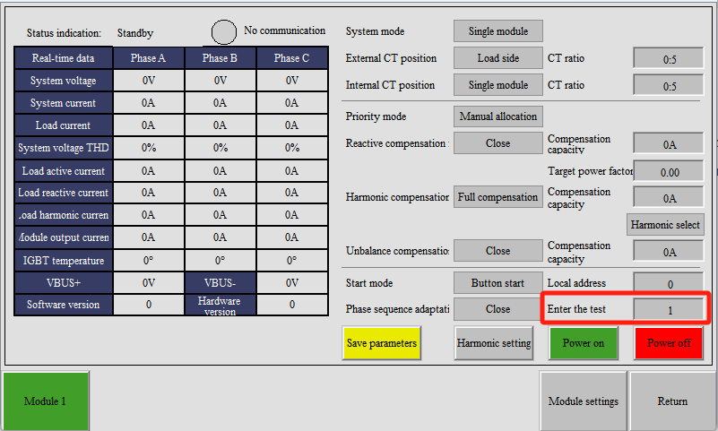

Harmonic generator has an additional test button. When it is set to 0, it is in normal AHF mode. When it is set to 1, it is in harmonic generator mode. At this time, the system mode is set to single module, load side, And no CT required.

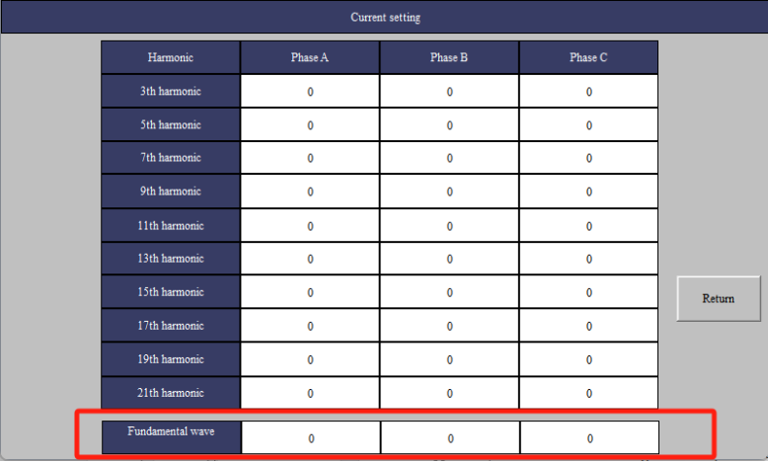

You can input numbers on this interface to emit corresponding harmonics(amperes)

Fundamental wave represents reactive power.  
Positive numbers represent inductive reactive power.  
Negative numbers represent capacitive reactive power.

# Event Log

Enter the event logging interface as shown in Figure 4-1. The event recording interface can view the status of the module's on-off event and the faults occurred during operation. It includes the detailed time of failure, fault code, fault name and key system parameters. Click on the horizontal slider ""and"" to see the corresponding parameter information, and the vertical slider "▲" and "▼" to see more event records.

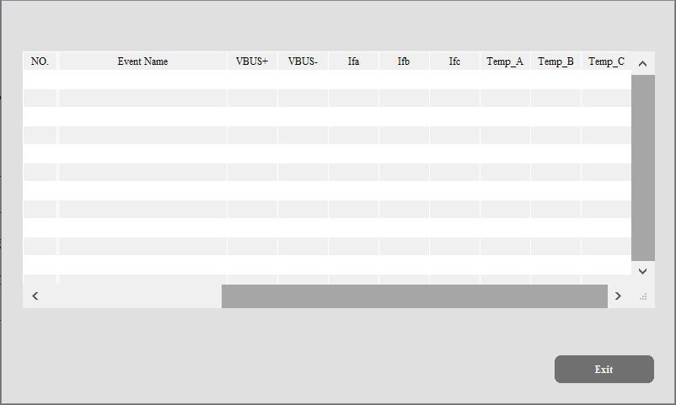

Figure 4-1 Event Log

# Description of Typical Application Parameter Setting

## Mode Selection and CT Setting

1. Parameter setting for single module application

|  |  |  |  |  |  |
| --- | --- | --- | --- | --- | --- |
| Application scenarios | System Mode | External CT Position Selection | Internal CT Position Selection | External CT Variable Ratio | Internal CT Variable Ratio |
| CT to load side | Single Module | Load Side | Single Module | the actual CT ratio | the actual CT ratio |
| CT to power side | Single Module | Power Side |

1. Related parameter setting for parallel application of multiple modules

|  |  |  |  |  |  |
| --- | --- | --- | --- | --- | --- |
| Application scenarios | System Mode | External CT Position Selection | Internal CT Position Selection | External CT Variable Ratio | Internal CT Variable Ratio |
| CT to load side | Multiple Module | Load Side | Multiple Module | the actual CT ratio /the module number | the actual CT ratio /the module number |
| CT to power side | Multiple Module | Power Side |

## Module Compensation Capacity Setting

For example, when a 75A APF module is used alone to compensate reactive power 25A and harmonic 50A, the reactive power compensation capacity =25A, the harmonic compensation capacity =70A (50A*1.4), and the unbalanced compensation capacity =0A.

|  |  |  |  |
| --- | --- | --- | --- |
| Reactive Compensation Capacity | Harmonic Compensation Capacity | Imbalanced Compensation Capacity | Module rated capacity |
| X | Y*1.4 | Z | P=X+Y+Z （A:安培） |
| Instructions | 1. The compensation capacity of each function should be set according to the actual demand, in units of A (ampere) (1kvar= 1.5A). 2. The reactive compensation capacity (X), harmonic compensation capacity (Y) and imbalanced compensation capacity (Z) of all parallel modules must be consistent. 3. When the harmonic compensation capacity is setted, the coefficient of 1.4 shall be multiplied. | | |