|  |  |
| --- | --- |
| 1641003869(1) | **1641168580(1)** |

**ACTIVE POWER FILTER**

**YTPQC-APF-400 Series**

**User Manual**

Model: YTPQC-APF-400

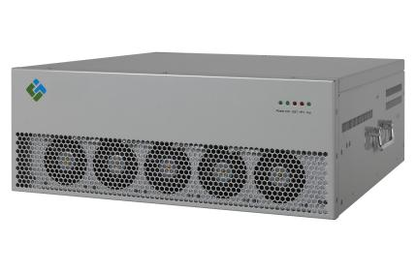

Rated Voltage: 400V*±15%

Rated Frequency: 60Hz

Version: V664

Tel: +86-21-33712042

Web: [www.ytelect.com](http://www.yt-electric.com)

1. Mail: [sales@yt-electric.com](mailto:service@yt-electric.com)



**SHANGHAI YINGTONG ELECTRIC CO.,LTD**

@All rights reserved, including but not limited to the application ownership.

At the same time, our company reserves the right to investigate the responsibility for acts of reproduction, transmission, dissemination without our permission.

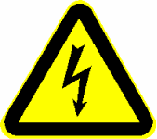**Safety Instructions (DANGER)**



1. The contents of this manual involve the installation and use of the comprehensive power quality control device (hereinafter referred to as the device), and the manual shall be read before installation.
2. The instructions are very important for users and the device. Ignoring them may cause serious damage to you and the device.
3. This device must be commissioned and maintained by our company or the engineer designated by its dealer; otherwise it may endanger personal safety and lead to the malfunction of the device, and the damage caused to this device thereby shall not be under warranty.
4. Only qualified personnel shall be allowed to operate the device, including installation, running, routine maintenance, removal, etc. The operation of the device by other personnel, excerpt technical personnel of the company and qualified users, is strictly prohibited.
5. Before the power is on, confirm that the device has been properly grounded. Poor grounding will easily lead to abnormal operation of the device and danger of electric shock.
6. When this device is disconnected from the power grid, it cannot be opened until at least 5 minutes later when the residual voltage of the DC capacitor of the energy storage unit inside the device is released; otherwise there will be risk of electric shock.
7. All electrical installation and routine maintenance must be carried out when the power is off.
8. Please do not try to maintain the device when it is running.
9. Electric shock may be deadly. Please do not touch live parts.
10. Arc sparks may hurt eyes, burn skin, damage this device and ignite explosive objects.
11. Prevent short circuit caused by tools during the process of installation and operation of this device. Be well prepared for taking safety protection measures.

**Notes (Warning)**



Make sure to read these warnings before installing and using this device.

1. This device is only for commercial / industrial purpose and cannot be used as an equipment associated with life support equipment.
2. After the installation of this device is completed, this device and its components cannot be moved or removed without the operation of the professional personnel of the company. It can only be operated within the operating range signed in the technical agreement and cannot be used for other purposes.
3. Please use and operate the device strictly in accordance with the electrical wiring diagram of the device provided by our company and the instructions in this manual, so as to prevent the device from being damaged and personal injury.
4. In the live line connection of the current transformer, first of all, make sure that its secondary side is in a short circuit state. The secondary side of the current transformer in operation shall not be disconnected.
5. Improper ventilation or poor heat dissipation will lead to overheating, causing damage to the device. It is not allowed to cover the vent of the device and ensure that it is far away from the heat source. The fan of this device shall be started normally. There shall be no abnormal phenomenon in operation, such as abnormal halt and abnormal noise, so as to ensure good heat dissipation of the device (Let cold air in in the front and hot air out on the back.).
6. This device shall be used in an environment free of conductive dust and corrosive substances.
7. In maintenance, make sure that the power of the equipment has been cut off and the operator has a safety watcher.
8. This device conforms to CE73 / 23 & 93 / 68 (low voltage safety) and 89 / 336 ( EMC), and its installation and use shall comply with the above requirements and the accessories designated by the manufacturer shall be used, otherwise, it will be deemed to automatically give up the quality assurance of the company.
9. **Mark:** The product model, factory number, capacity, weight and production date of the device are indicated on the nameplate. Please confirm the specification of the equipment when using it.
10. **Transportation:** During transportation, make sure that the stress direction of the device is consistent with the fixed direction, and it cannot be placed upside down or sidelong.Prevent it from direct physical impact and vibration, from rain and water immersion, from burning by high temperature, and from corrosion by salt fog.
11. **Receiving and inspection of equipment:** This device has been thoroughly tested and inspected before being delivered, and the transportation preparation has been made according to the requirements of safe transportation. However, during long-distance transportation, the retaining elements of the device may still become loose due to vibration and bump. Therefore, please check as follows after receiving the device:
12. Visually inspect whether the packaging box transported is damaged or not. In case of any damage, request the forwarding agent to check the transportation situation and record the damage on the transport receipt.
13. Try to be careful when disassembling the packaging box. If the packaging box is to be disassembled with bars or hammers, please be careful to avoid damage to the device.
14. Visually inspect that there is no external damage on the device, such as scratch, paint-shedding, sinking, etc. Check for loose components and wiring. If there is damage during transportation, please contact us.
15. Carefully check the delivery note to ensure that the model and quantity of the goods are correct. If you have any questions, please contact us at the first time.
16. **Storage:** make sure to prevent it from direct physical impact and vibration, from rain and water immersion, from burning by high temperature, and from corrosion by salt fog, from being stored in a dusty environment during storage.The packaging of this device can be stored indoors for 6 months (starting from the date of delivery). The warehouse shall be kept dry and ventilated with no corrosive substances, no strong mechanical vibration, impact and the action of a magnetic field.
17. **Long term storage:** If the storage time of your device exceeds one year, the electrolytic capacitor shall be recharged.If it is not recharged, the electrolytic capacitor may be damaged so that the device cannot work normally.



**Notes (Warning)**

**Dangerous voltage: All operations (including opening the housing of this device, removing or installing connecting cables) can only be done by professionals.**

**Security: The grounding terminals on this device must be reliably grounded. Request the qualified electrical engineer to confirm that the device is fully grounded.**

Contents

Chapter I Device Description 5

1.1 An Introduction to the Device 5

1.1.1 Device Features 5

1.1.2 Device Parameters 5

1.2 Appearance and Installation Dimension 6

1.3 Technical Data 10

Chapter II Installation and Electrical Connection 11

2.1 Installation Instructions 11

2.2 Requirements for Vent 13

2.3 Primary and Secondary Interfaces of the Device 13

2.4 Panel Indicator Light and Debugging Interface of the Device 26

2.5 External LCD Screen of the Device(Human Machine Interface) 26

Chapter III Commissioning Instructions of the Device 28

3.1 Start and Shutdown of the Device 28

3.1.1 Starting Mode 28

3.1.2 Starting Steps 28

3.1.3 Shutdown Mode 28

3.2 Display Interface of the Device 29

3.3 Pilot Run Steps 29

3.3.1 Inspecting Items 29

3.3.2 Start of the Device 29

3.3.3 Observation of Compensation Effect 29

Chapter IV Communication Protocol 30

4.1 Communication Settings 30

4.2 Data Type 30

4.3 Function Codes 30

4.4 Communication Protocol 31

Chapter V Repair and Maintenance 33

5.1 Routine Maintenance 33

5.2 Precautions 33

5.3 Fault Judgement 33

Chapter VI Wall Mounted Module 34

Chapter VII Free landing Cabinet 35

**Chapter I Device Description**

* 1. **An Introduction to the Device**
     1. **Device Features**
* This device has various compensation modes (harmonic, reactive power, three-phase unbalance and capacitor switching control), which can simultaneously make the said various compensation, and compensation capacity for harmonic, reactive power, and three-phase unbalance can also be set freely, comprehensively solving the problem of power quality of the low-voltage power distribution side;
* The device can filter out 2nd to 50th odd order harmonics at the same time, and specific order harmonics (2nd to 50th odd, selective) can be filtered out according to the setting.
* The device can dynamically and smoothly compensate inductive and capacitive reactive power, and the power factor of the system after compensation is greater than 0.99;
* The unbalance degree of the three-phase active load current of the system after compensation within the rated capacity is less than 5%;
* Fast response, high controllability, automatic current limiting function and no overload;
* Whether it is harmonic filtering, reactive power compensation or three-phase unbalance compensation, the device can automatically compensate according to the harmonic current, reactive power and three-phase unbalance load of the system. The problem of overcompensation will not occur.
* It features modular design, a variety of installation methods, such as rack-mounted type and wall-mounted type, etc., and multiple devices can operate in parallel, so as to meet the actual needs to the greatest extent.
* It has a function of multiple protection against over-current, over-voltage, over-temperature, phase sequence error and default phase, etc.
* It is configured with RS485 and CAN standard communication interfaces, which can make it exchange information with other unit devices, and it can also be configured with wired / wireless communication modules to realize remote data monitoring.
  + 1. **Device Parameters**

|  |  |
| --- | --- |
| Operating voltage | 400V*±15% |
| Operating frequency | 60Hz±5% |
| Main circuit structure | Three Phase Four Wire |
| Rated capacity(Module) | 25A,50A, 75A, 100A, 125A, 150A |
| Circuit topology | Three-level structure |
| Multi devices in parallel | Up to 12 sets can be connected in parallel |
| Response time | ≤5ms |
| Efficiency of single machine | ≥98% |
| Working mode | Harmonic compensation, reactive power compensation, three-phase load unbalance compensation. |
| Harmonic filtering | The device can filter out harmonics 2nd to 50th odd orders at the same time(Full), and specific order harmonics(between 2nd to 50th odd) can be filtered out by setting(selective) |
| Current limit | The compensating current is automatically limited within the rated current range. |
| Compensation effect  (At sufficient capacity) | Total harmonic current distortion rate (THDi) ≤ 5%;  Reactive power factor ≥0.99;  Three-phase unbalance degree≤ 5%; |
| Display Interface | External 7” HMI or built-in HMI |
| Display status | Displayed in a data mode |
| Operations | Manual start, automatic start |
| Communication | RS485, Modbus communication protocol |
| Environment temperature | -20 ~ 55 ℃ (rated power output) |
| Storage temperature | -30～70℃ |
| Relative humidity | 95 % at a maximum, no condensation |
| Altitude | Below 1500 meters above sea level |
| Cooling requirements | Require well ventilation, and the air vent can be opened through the cabinet door, or a fan installed in the cabinet. |

Note:

1. The above parameters can be reached when the compensating current reaches 50% of the rated capacity and above.
2. If devices need mitigate even order harmonics, inform us in advance.
3. If devices need control capacitors, inform us in advance.
   1. **Appearance and Installation Dimension**

The device capacity is divided into 50A,75A,100A,125A,150A. And each device can be operated in any parallel combination, the external dimensions of 50A,75A are completely the same, and 125A and 150A are completely the same . Please refer to the following figure for specific external dimensions.

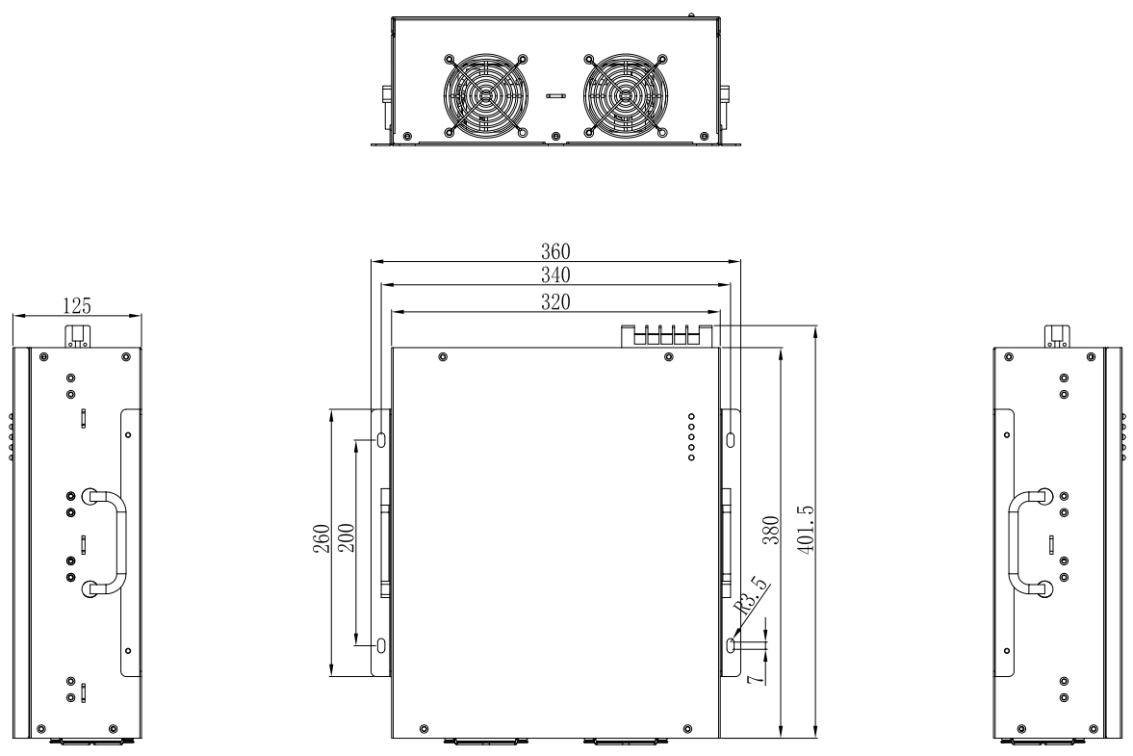

Figure 1 - 1 Overall Dimension Drawing (Unit: mm) of Rack Module (25A)

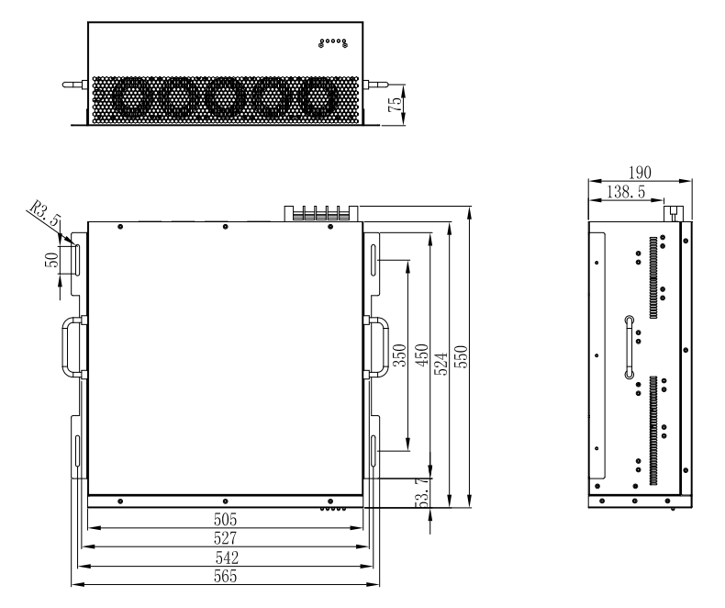

Figure 1 - 2 Overall Dimension Drawing (Unit: mm) of Rack Module(50A)

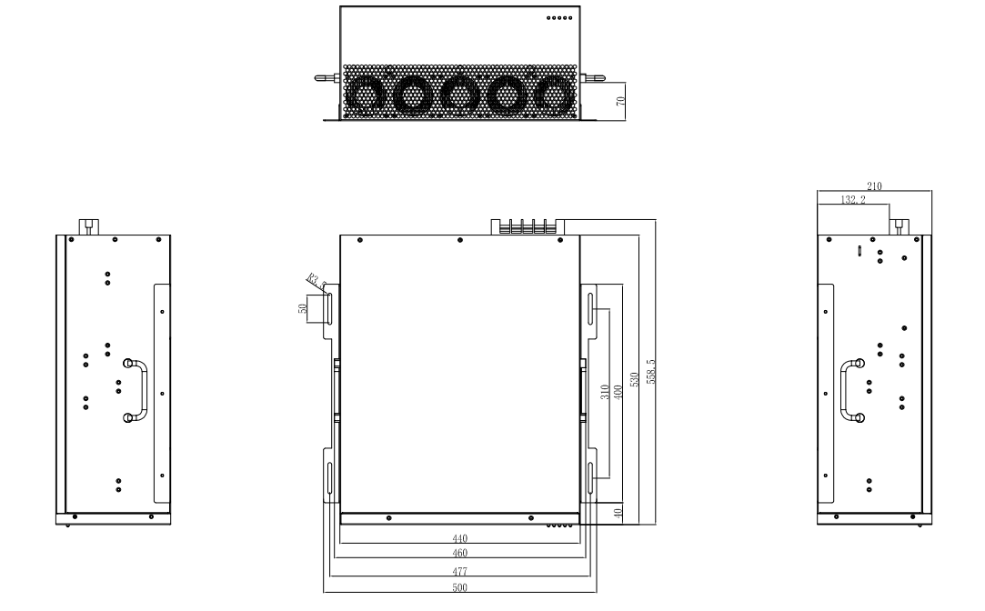

Figure 1 - 3 Overall Dimension Drawing (Unit: mm) of Rack Module(75A，100A)

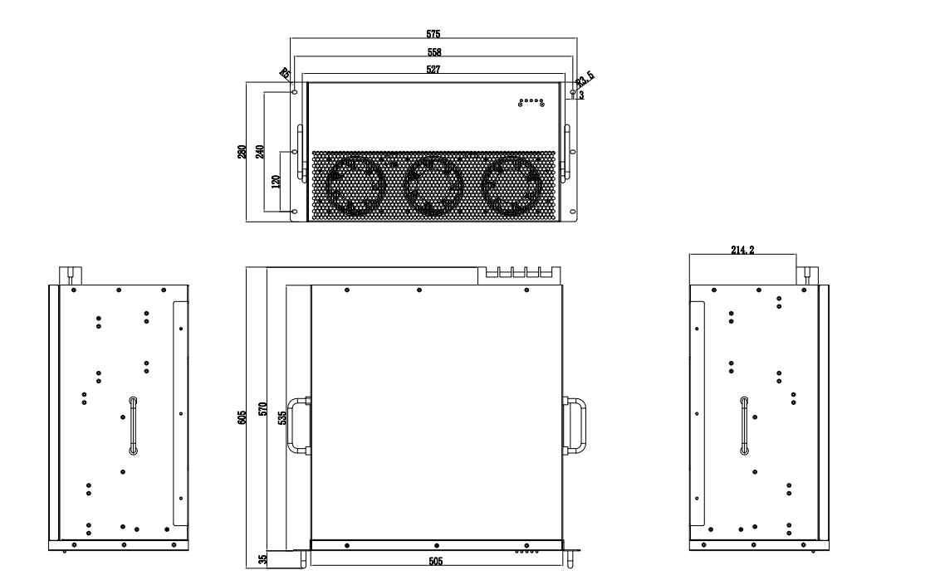

Figure 1 -4 Overall Dimension Drawing (Unit: mm) of Rack Module(150A)

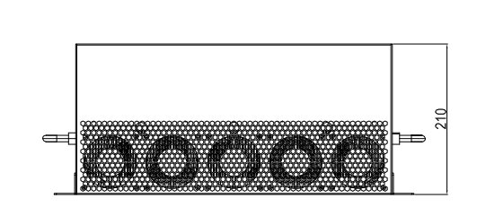

Figure 1-5 Front View

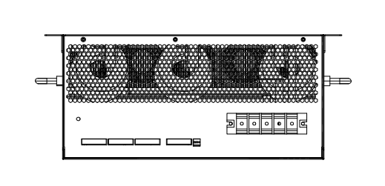

Figure 1-6 Back View

**1.3 Technical Data**

Table 1-1 Technical Data

| **Rated capacity** | 25A | 50A | 75A | 100A | 150A | |
| --- | --- | --- | --- | --- | --- | --- |
| Cooling mode | Air cooling | | | | | |
| Environment temperature | -20～55℃ | | | | | |
| Parallel operation | When multiple devices are running in parallel, refer to Table 2-9 for the selection of transformer and 2.3.5 for the connection method. | | | | | |
| Current transformer | 50:5～10000:5 | | | | | |
| Power consumption | ≤ 2.5% of rated capacity | | | | | |
| Requirements for air volume | ≥120m3/h | ≥200m3/h | ≥350m3/h | ≥500m³/h | ≥800m³/h | |
| Grid frequency | 60Hz±5% | | | | | |
| Grid voltage | 400V±20% | | | | | |
| Connection mode | 3 phase +N+PE | | | | | |
| Protection grade | IP20(Standard)/IP30/IP40 | | | | | |
| Overall Dimension  (WxDxH)mm | 320x400x125 | 505x550x190 | 440x560x210 | 440x560x210 | | 565x569x280 |
| Weight | 17kg | 30kg | 37kg | 39kg | | 55kg |

**Chapter II Installation and Electrical Connection**

* 1. Installation Instructions

Table 2-1 Installation Space of the Device

|  |  |
| --- | --- |
| **Position** | **Requirements for Installation Space** |
| Front end (air inlet) | ≥ 100 mm, or a vent is made at the air inlet of the corresponding module of the cabinet |
| Rear end (air outlet) | ≥ 200 mm, or a vent is made at the air inlet of the corresponding module of the cabinet |
| **Note: If the depth of the cabinet cannot meet the minimum requirement for installation space, air holes of the same size must be made at the inlet / outlet of the corresponding module on the front and rear cabinet doors of the cabinet. Please do not add filter cotton to the air holes.** | |

The conventional mode of the device is a rack-mounted type, which is installed horizontally in the cabinet and fixed by 4 location holes. Refer to Figure 2-1 for the installation mode. (Note: **If you need vertical installation or wall-mounted installation, please contact the technical support or sales personnel of the company.)**

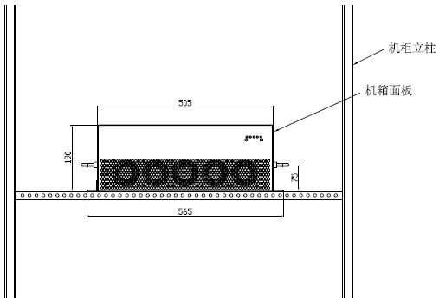

Enclosure panel

Cabinet posts

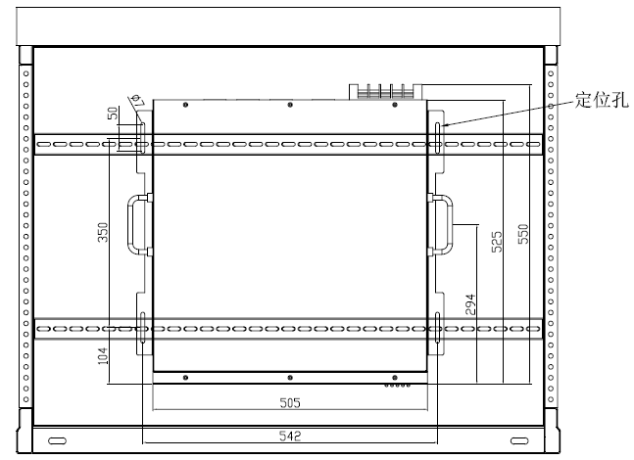

Location hole

Figure 2-1 Rack Installation Diagram of Devices

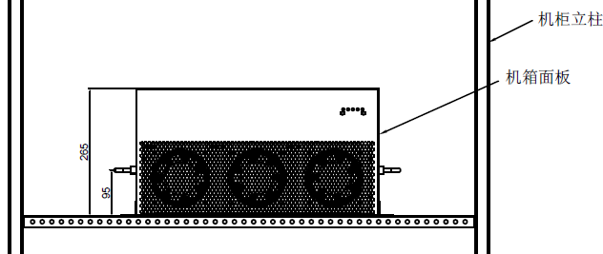

Enclosure panel

Cabinet posts

Figure 2-2 Rack Installation Diagram of the Device

* 1. Requirements for Vent

Power-type power electronic components are used in the device, which will generate a large amount of heat during operation. In order to ensure the normal and reliable operation of the device, the cabinet must have good measures for ventilation and heat dissipation.

When the centralized panel is installed in the device, the requirements of the cabinet for heat dissipation are as follows:

1. The front and rear doors of the cabinet must be provided with air hole s, for which the requirements are as follows:

* With respect to holes for the front panel of the cabinet corresponding to the front air inlet of the device, their area shall be no less than that of the front air inlet of the device;
* With respect to holes for the rear panel of the cabinet corresponding to the rear air outlet of the device, their area shall be no less than that of the front air outlet of the device;
* Filter cotton cannot be added to the air holes, so as to prevent dust, impurities, etc. from blocking the air holes.

1. If the cabinet is equipped with ventilation and heat dissipation, such as fans, the air volume requirements of a single device are as follows:

Table 2-2 Requirements for Air Volume of Ventilation

|  |  |
| --- | --- |
| **Capacity** | **Air Volume Requirements** |
| 50A | ≥200m3/h |
| 75A | ≥350m3/h |
| 100A | ≥500m3/h |
| 125A | ≥800m3/h |
| 150A | ≥800m3/h |

* 1. **Primary and Secondary Interfaces of the Device**

|  |  |
| --- | --- |
| **DANGER** | **Dangerous voltage:**  **Short circuit and electric shock caused by ungrounded connection or a contact with liquid can lead to fatal danger.**  It must be ensured that this device module is grounded.  It is not allowed to assemble this device in an environment with liquid.  It is not allowed to expose this device to an environment with condensation.  The cover / door can only be removed or opened under the condition that this device is completely powered off and the capacitor has sufficient time (no less than 5 minutes) for discharging. |

**2.3.1 Location of Primary and Secondary Terminals of the Device**

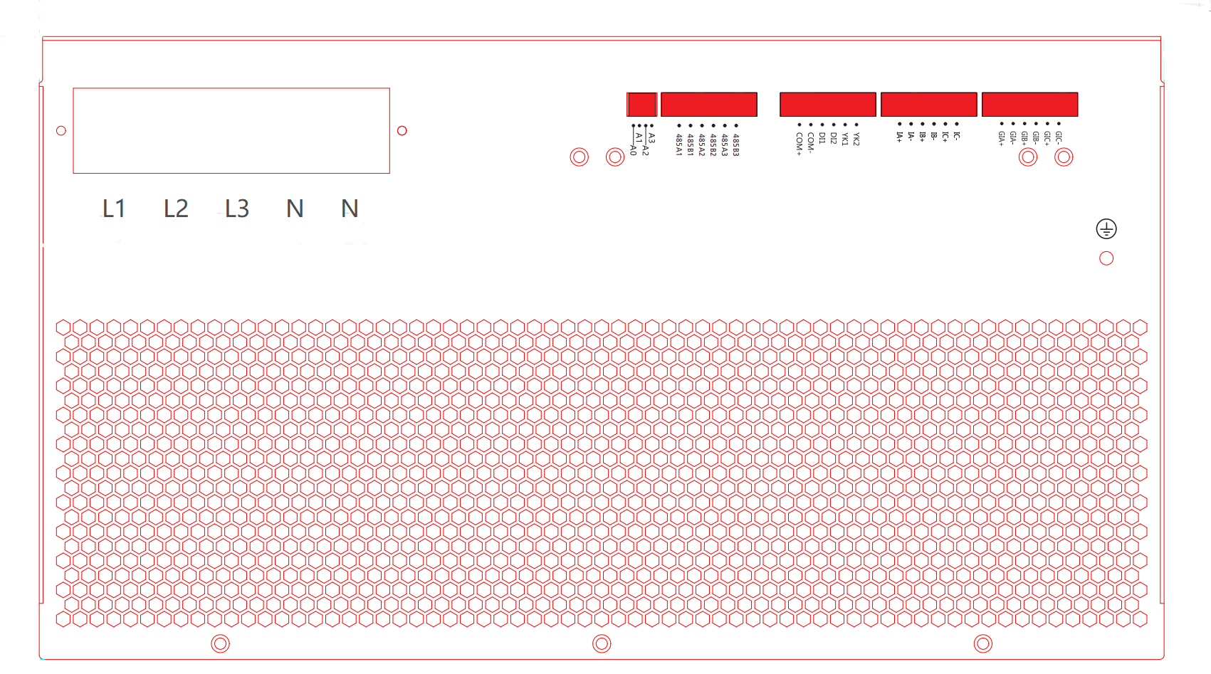

Figure 2-3 Terminal Position Diagram of Devices

**Note: All devices with different capacities are identical in terminal sequence and definition, and only slightly vary in the position and size of L1/L2/L3/N main terminals.**

**2.3.2 Model Selection Table of Power Distribution Cable of the Device**

This device has five external power terminals. Please refer to Table 2-3 for Model Selection of Cables.

* Input A - Phase A input end of mains supply
* Input B-Phase B input end of mains supply
* Input C-Phase C input end of mains supply
* Input N-Zero line input end of mains supply
* Input N-Zero line input end of mains supply

Table 2-3 Model Selection Table of Device Cables

|  |  |  |  |  |
| --- | --- | --- | --- | --- |
| Item | Parameter Requirements | | | |
| CT ratio range | 50:5～20000:5 | | | |
| CT cable | CT rated load | Cross sectional area of conductor | Length of one-way connection | |
| 5VA | 2.5mm2 | ≤10m | |
| 4.0mm2 | 10～20m | |
| 10VA | 2.5mm2 | ≤20m | |
| 4.0mm2 | 20～40m | |
| 15VA | 2.5mm2 | ≤30m | |
| 4.0mm2 | 30～60m | |
| Power cable  (A/B/C/N/PE) | Capacity | A/B/C | N | PE |
| 50A | 16mm2 | 2x16mm2 | 16mm2 |
| 75A | 25mm2 | 2x25mm2 | 16mm2 |
| 100A | 35mm2 | 2x35mm2 | 16mm2 |
| 125A | 50mm2 | 2x50mm2 | 25mm2 |
| 150A | 50mm2 | 2x50mm2 | 25mm2 |
| If there is a requirement for cable temperature, a higher specification of the cable is needed. | | | |

**2.3.3 Fuse Protection of Input End of the Device**

It is recommended to install fuses at the inlet of the device for protection. See Table 2-4 for fuse parameters.

Table 2-4 Recommended Fuse Parameters Table

|  |  |  |  |  |  |
| --- | --- | --- | --- | --- | --- |
| Rated capacity of the module | 25A | 50A | 75A | 100A | 150A |
| Rated current of the fuse | 50A | 80A | 125A | 160A | 250A |
| Fuse type | aR/gG | aR/gG | aR/gG | aR/gG | aR/gG |

**2.3.4 Description of Secondary Terminals of the Device**

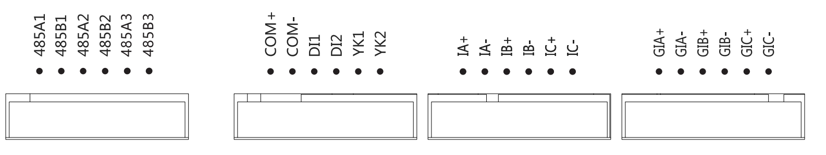

Figure 2 - 4 Definition of Secondary Terminal of the Device

Table 2 - 5 Description of Port 1 of Secondary Connection

|  |  |  |  |
| --- | --- | --- | --- |
| Serial Number | Mark | Description | Remarks |
| 1 | 485A1 | No.1 RS485 Port A | RS485 in Line 1  (It is standby, which can be connected to the intelligent capacitor or the RS485 port of other device.) |
| 2 | 485B1 | No.1 RS485 Port B |
| 3 | 485A2 | No. 2 RS485 Port A | 485 Port in Line 2  (parallel operation of modules, LCD screen, HMC panel) |
| 4 | 485B2 | No. 2 RS485 Port B |
| 5 | 485A3 | No. 3 RS485 Port A | Can communication interface (standby) |
| 6 | 485B3 | No. 3 RS485 Port B |

Table 2 - 6 Description of Port 2 of Secondary Connection

|  |  |  |  |
| --- | --- | --- | --- |
| Serial Number | Mark | Description | Remarks |
| 7 | COM+ | DC24V+ | DC power output: 24V, power: 25W power, which can be used as the power supply of external LCD or other controller |
| 8 | COM- | DC24V- |
| 9 | DI1 | Start signal of the Device (remote signal input) | DI1 and COM- are connected to normally open inching button. |
| 10 | DI2 | Shutdown signal of the Device (remote signal input) | DI2 and COM- are connected to normally closed inching button. |
| 11 | YK1 | Operation instruction of the Device (relay output) | YK1 and COM- are connect with 24V DC indicator light, which is on when running. |
| 12 | YK2 | Failure instruction of the Device (relay output) | YK2 and COM- are connect with 24V DC indicator light, which is on when it breaks down. |

Table 2 - 7 Description of Port 3 of Secondary Connection

|  |  |  |  |
| --- | --- | --- | --- |
| Serial Number | Mark | Description | Remarks |
| 13 | IA+ | Phase A S1 terminal of system / load current transformer | Sampling transformer input signal, also known as external CT current input signal, of which the CT can be installed on the load side or system side, and it is preferred to install it on the load side in design. |
| 14 | IA- | Phase A S2 terminal of system / load current transformer |
| 15 | IB+ | Phase B S1 terminal of system / load current transformer |
| 16 | IB- | Phase B S2 terminal of system / load current transformer |
| 17 | IC+ | Phase C S1 terminal of system / load current transformer |
| 18 | IC- | Phase C S2 terminal of system / load current transformer |

Table 2 - 8 Description of Port 4 of Secondary Connection

|  |  |  |  |
| --- | --- | --- | --- |
| Serial Number | Mark | Description | Remarks |
| 19 | GIA+ | Phase A S1 terminal of current transformer in the compensating cabinet | When a single module works, the signal does not need to be connected; When multiple modules are used in parallel or capacitors are used for compensation, a measuring transformer must be installed. The internal CT measures the total output current of the compensation cabinet (the compensating current of all modules and capacitors). |
| 20 | GIA- | Phase A S2 terminal of current transformer in the compensating cabinet |
| 21 | GIB+ | Phase B S1 terminal of current transformer in the compensating cabinet |
| 22 | GIB- | Phase B S2 terminal of current transformer in the compensating cabinet |
| 23 | GIC+ | Phase C S1 terminal of current transformer in the compensating cabinet |
| 24 | GIC- | Phase C S2 terminal of current transformer in the compensating cabinet |

**2.3.5 Connection Diagram of Secondary Terminals of the Device**

2.3.5.1 Connection Diagram of Start / Stop Button

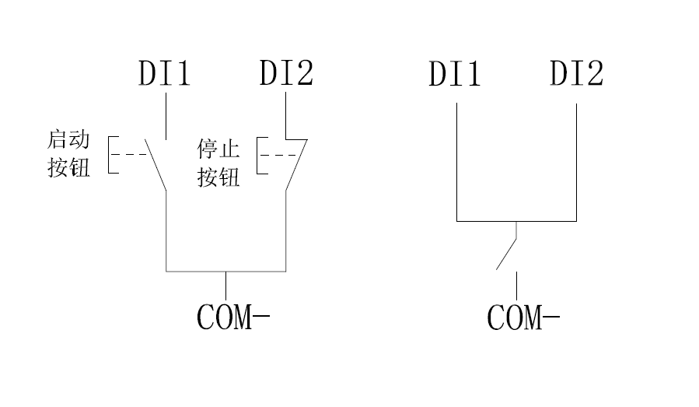

Start button

Stop button

Figure 2 - 5 Start and Stop Controlled by Buttons

When the device is started by a button, there are the above two modes of connection:

1. If the inching button is used, DI1 is connected to the normally open button, which is the start button. DI2 is connected to the normally closed button, which is the stop button, as shown in the above left figure.
2. If the changeover switch is used, the device is started when it is closed while the device is shut down when it is disconnected, as shown in the above right figure.

2.3.5.2 Operating Condition Indicator Light

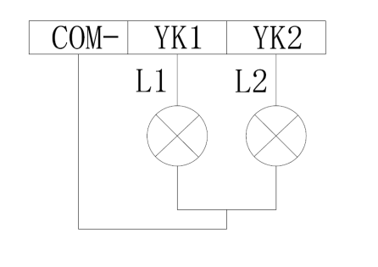

Figure 2 - 6 Fault and Operation Indicator Light

When it needs to be connected to external operating condition indicator light, YK1 and YK2 output DC 24V signals through relays. When L1 is on, it indicates that the device is running, and when L2 is on, it indicates a fault.

2.3.5.3 RS485 Interface

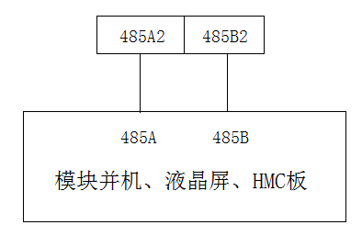

Parallel operation of modules LCD screen HMI

Figure 2-7 RS485 Communication Connection Diagram

RS485 communication shall be used when multiple machines of this device are connected in parallel. when more than eight devices are connected in parallel or the transmission distance exceeds 300 meters, a 120 Ω resistor needs to be connected in parallel to each end of the communication line.

RS485 cable is usually STP cable. One end of the shielding layer is connected to the cabinet floor while the other end is suspended.

For the connection of RS485 for multiple devices, they must be connected hand in hand. Star connection or branch is not allowed. The connection is shown in Figure 2 - 8:

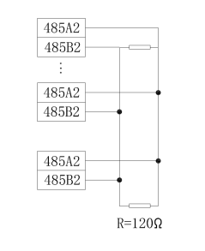

Figure 2-8 RS485 Communication Diagram for Multiple Parallel Machines

2.3.5.4 Connection of Current Transformer

|  |  |
| --- | --- |
| **DANGER** | **Dangerous voltage:**  **If the current transformer is not correctly connected, it may lead to open circuit of CT, damage CT or endanger human body.**   * When connecting the current transformer, the secondary side of the transformer must be short-circuited, so as to ensure that the current transformer remains short-circuited until the CT terminal blocks of the device are connected. * When detaching this device, the secondary side of the transformer needs to be short-circuited. |

**Please follow the rules listed below:**

* The current transformer P1 is close to the system side and P2 is close to the load side.
* S1 of the current transformer is connected to the current input terminal (+), and S2 is connected to the current output terminal (-);
* The input signal of the current transformer must be equipped with a current test terminal to facilitate installation and debugging of the device.
* When more than one device run in parallel, the current transformer must be installed on the load side. When only one device operates independently, the current transformer can be connected to either the system side or the load side, and the load side is preferred.
* The current transformer must be specialized, and the secondary side of the transformer must not be connected to other induction loads in series.

Table 2 - 9 Specifications of Current Transformer

|  |  |
| --- | --- |
| **Content** | **Parameter Value** |
| Rated output current | 5 A |
| Rated output power | ≥ 5.0 VA (1 ~ 5 units of device(s) running in parallel)  ≥ 10.0 VA (6 ~ 10 units of devices running in parallel) |
| Precision grade | 0.5 (or higher) |
| Rated input current | CT primary rated current is generally 1.5-2 times of the rated current of the transformer. |

1. Connection of current transformer when single device is running

* Filter sampling transformer (external CT) can either be installed on the load side or the system side, and it is preferred to install it on the load side.
* Confirm the installation direction (P1 is close to the system side and P2 is close to the load side.) and phase sequence of the current transformer, so as to ensure the normal operation of the device.

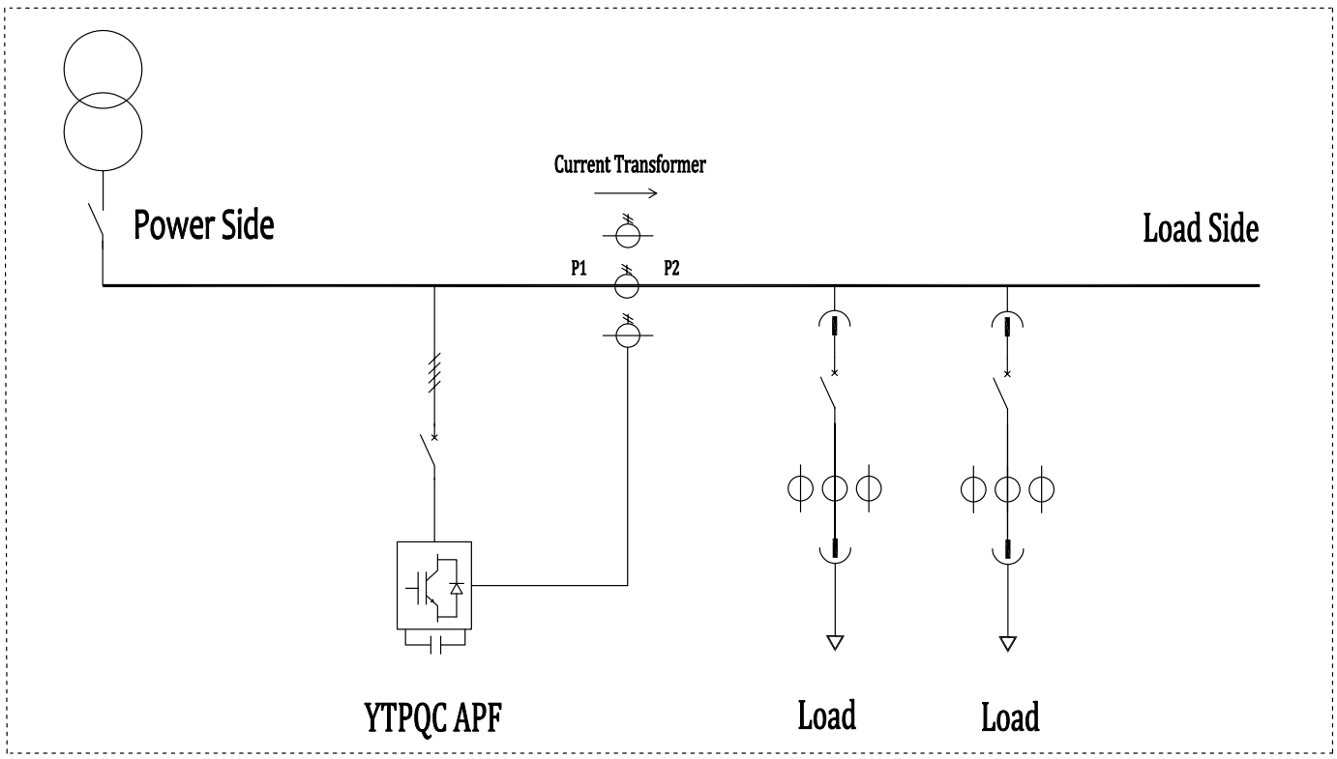

Figure 2-9 CT is at load side when single device is in operation (Preferred)

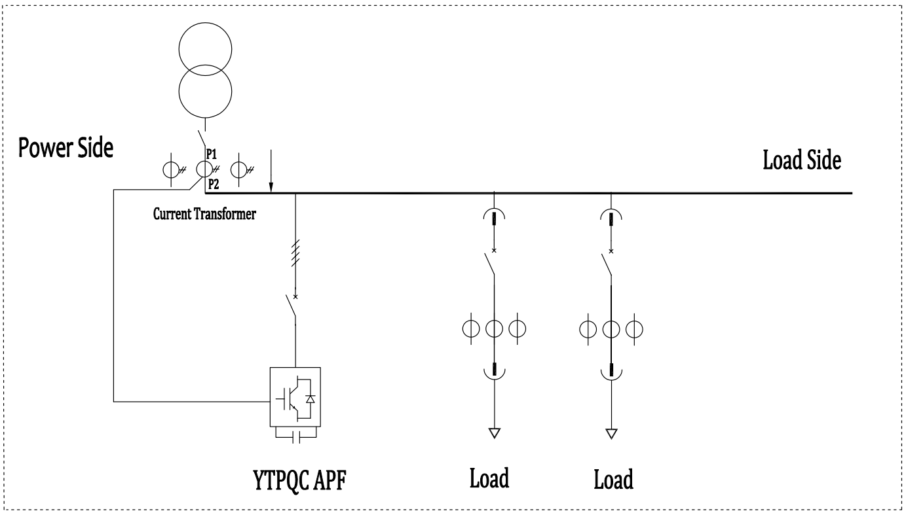

Figure 2 - 10 CT is at power side when a single device is running

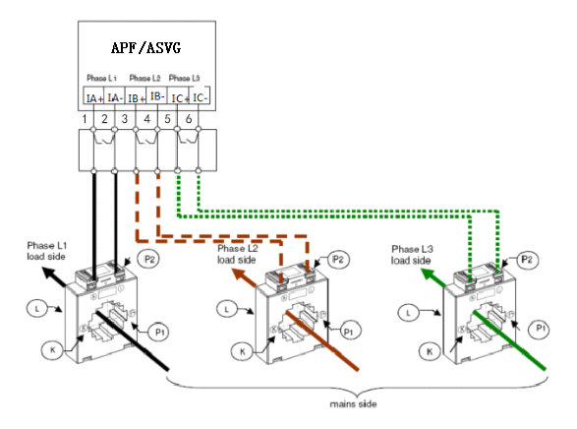

Figure 2 - 11 Connection of current transformer when single device is running

**Instructions for CT installation and connection:**

* **The current transformer P1 is close to the system side and P2 is close to the load side (The line enters at P1 and goes out at P2.);**
* **S1 of the current transformer is connected to the current input terminal (+), and S2 is connected to the current output terminal (-);**
* **The input signal of the current transformer is equipped with a current test terminal on the cabinet.**

1. Connection of current transformer when multiple devices are running

The parallel operation of multiple devices can increase the compensation current value. When connected in parallel, multiple devices share a group of sampling current transformers, and the current signals of the sampling current transformers are connected to all devices connected in parallel, as shown in the following figure. The current transformer can either be installed on the load side (preferred) or the system side. When multiple devices are connected in parallel, a measuring current transformer must be installed in the cabinet to measure the total compensating current of all devices.

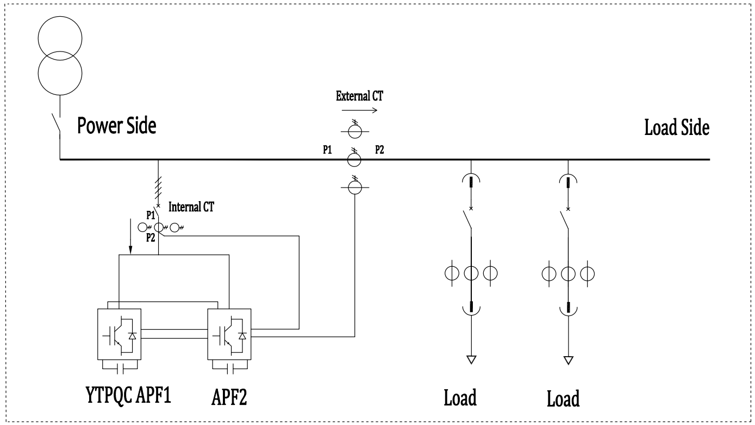

Figure 2-12 CT is installed at load side when devices are running in parallel (Preferred)

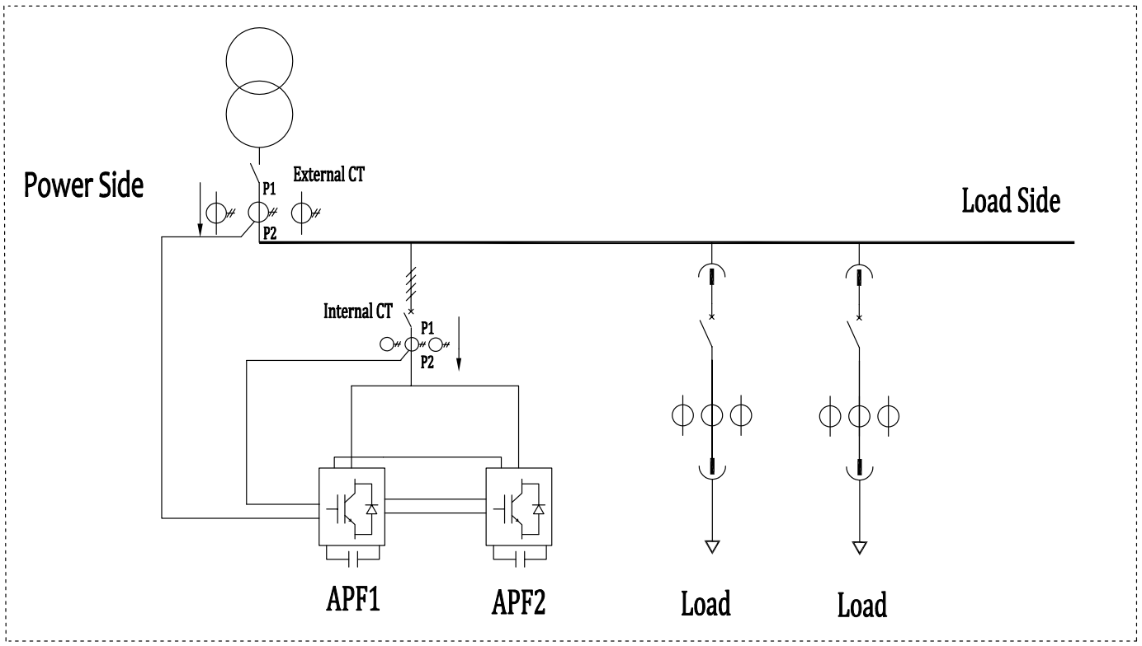

Figure 2-13 CT is installed at power side when devices are running in parallel

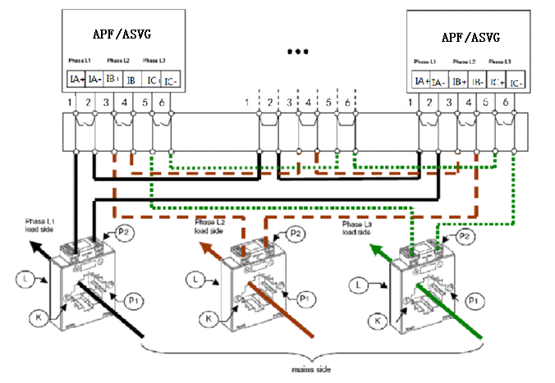

Figure 2-14 Connection of current transformer when devices are running in parallel

When devices are connected in parallel, the external sampling CT signals are serially connected to each device in turn, and the connection is shown in Figure 2 - 14.

According to Table 2-9 Specification Table of Current Transformers, a current transformer can be connected with up to five devices. When more than five devices are connected in parallel, the current transformer with stronger load output capacity shall be selected or more current transformers shall be provided.

**Instructions for CT installation and connection:**

* **The external current transformer P1 is close to the system side and P2 is close to the load side (The line enters at P1 and goes out at P2.);**
* **The internal current transformer P1 is close to the system side and P2 is close to the load side (The line enters at P1 and goes out at P2.);**
* **The secondary side current of the current transformer flows through all devices connected in parallel in turn;**
* **S1 of the current transformer is connected to the current input terminal (+), and S2 is connected to the current output terminal (-);**
* **The input signal of the current transformer and the current input signal of all devices are all equipped with current test terminals on the cabinet.**

(3) Single device + capacitor hybrid compensation cabinet

In hybrid compensation, the device needs to control the capacitor for reactive power compensation in addition to completing harmonic or reactive power compensation, wherein the internal CT measures the total compensating current of all modules and capacitors, and the external CT measures the current of the load side (preferred scheme). If the external CT measures the current of the system side, it must ensure that there is no other current of reactive compensation device in the CT sampling current on the system side.

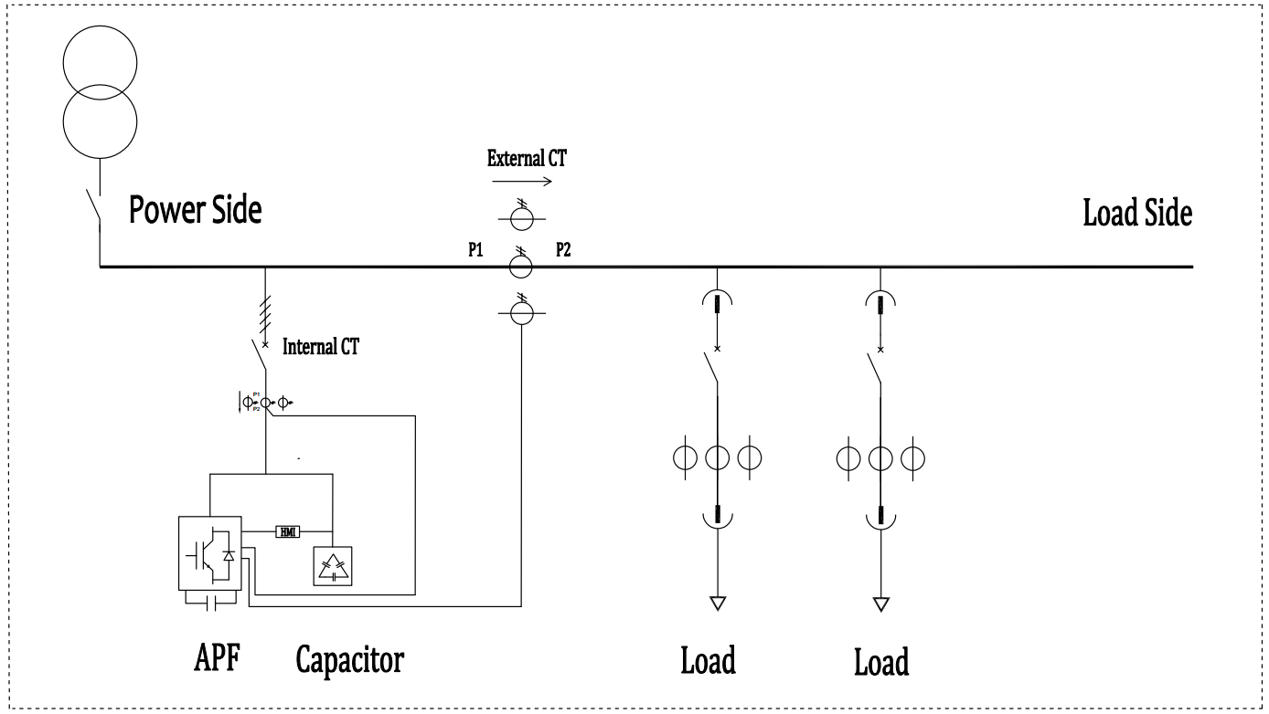

Figure 2-15 The external CT is installed at load side (preferred scheme)

**Note: At this condition, If all the current of APF are set for reactive power compensation (working as SVG,), External CT should be connected before Capacitor banks.**

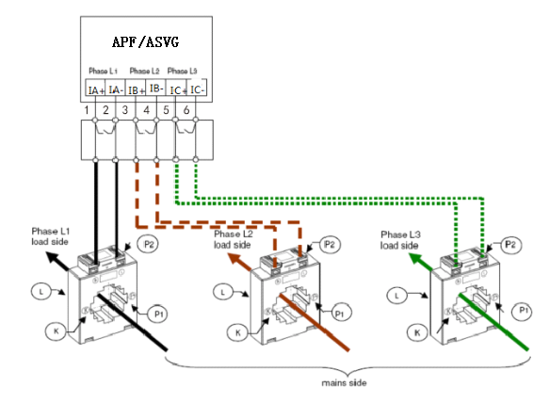

Figure 2-16 Connection Diagram of CT in Hybrid Compensation

* 1. **Panel Indicator Light and Debugging Interface of the Device**

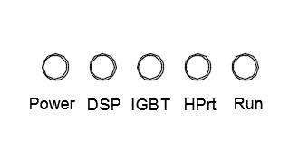

Figure 2-17 Schematic Diagram of Panel Indicator Light of the Device

As the description of status indicator light shown in Figure 2-17:

Power - Indication of the power supply of circuit board;

DSP - Indication of the operation of DSP, which flashes with an interval of 1 second.

IGBT - Indication of IGBT fault, when an IGBT fault occurs, it becomes normally on;

HPrt - Indication of a fault, which becomes normally on when faults other than IGBT fault occur.

RUN - Operation indicator light of the device, which is always on when it begins to operate and off when it stands by.

**2.5 External LCD Screen of the Device(Human Machine Interface)**

The LCD screen is connected to No. 2 RS485 Port of the device (terminal mark: 485A2, 485B2).

Refer to HMI User Manual.

2.3.5.5 Connection of Current Transformer

Dial up (near the ON side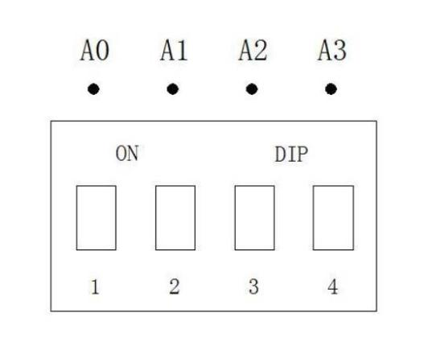) represents 1, and down represents 0.The code switch corresponds to the 485 communication address shown in the following table.

|  |  |  |  |  |
| --- | --- | --- | --- | --- |
| Code position,Up:1,Down:0 | | | | Module Address |
| A0 | A1 | A2 | A3 |
| 0 | 0 | 0 | 0 | 0（Software setting address） |
| 1 | 0 | 0 | 0 | 1 |
| 0 | 1 | 0 | 0 | 2 |
| 1 | 1 | 0 | 0 | 3 |
| 0 | 0 | 1 | 0 | 4 |
| 1 | 0 | 1 | 0 | 5 |
| 0 | 1 | 1 | 0 | 6 |
| 1 | 1 | 1 | 0 | 7 |
| 0 | 0 | 0 | 1 | 8 |
| 1 | 0 | 0 | 1 | 9 |
| 0 | 1 | 0 | 1 | 10 |
| 1 | 1 | 0 | 1 | 11 |
| 0 | 0 | 1 | 1 | 12 |
| 1 | 0 | 1 | 1 | 13 |
| 0 | 1 | 1 | 1 | 14 |
| 1 | 1 | 1 | 1 | 15 |

**Chapter III Commissioning Instructions of the Device**

* 1. **Start and Shutdown of the Device**
     1. **Starting Mode**

The device is started in three modes, namely, communication start, automatic start, and DI start, which can all be set through the external LCD screen.

* Communication start: The start of the device can be controlled through the LCD screen.
* Automatic start: The device starts automatically after the device is powered on. For the shutdown caused by a fault or abnormal communication during normal operation, after the fault is removed, the device can be started automatically. In the mode of automatic start, the device can be shut down through the stop button.
* DI start: It can be manually started through the button on the cabinet.

Note: You can only choose one of the three starting modes, and there are no multiple choices, but you can choose more than one modes for shutdown.

* + 1. **Starting Steps**

After the device is set to the mode of automatic start, if there is no fault with the device after the power is on, the device will automatically start. If it is set to DI start, it can be started by an external button or the changeover switch. If it is set to the communication start, the device can be started or shut down through the LCD screen.

* + 1. **Shutdown Mode**

The device can be shut down in three modes:

* Direct power off of the module (emergency shutdown mode): Directly disconnect the breaker or disconnector between the device and the mains supply, in which the device is not charged and relevant maintenance can be carried out. (Note: The use of emergency shutdown mode is prohibited in normal operation. Due to the presence of internal electrolytic capacitors, it is strictly prohibited to open the housing of the device within five minutes after the power is cut off).
* Shutdown through LCD screen: Use “on / off” options on LCD screen to shut down the device.
* Shutdown through button: It can be manually shut down through the button on the cabinet.

The LCD screen and button can only shut down the operation of IGBT power devices in the system. However, because the bus and auxiliary power supply of the device are still charged, the relevant control systems remain standby.

* 1. **Display Interface of the Device**

The device itself does not have an LCD screen, and you can use the supporting external LCD controller provided by our company. The LCD controller can display the voltage, current, harmonic, power factor of the system, device output current, etc. in real time. Relevant parameters can be set, such as: Starting mode, CT ratio, compensation method, compensation ratio, etc. It can record and save fault information and relevant data when the device is running.

* 1. **Pilot Run Steps**

**3.3.1 Inspecting Items**

1. The grounding of the device housing;
2. Whether the incoming line of the power supply is correct and whether the voltage is normal;
3. Whether CT is correctly installed; whether the installation direction is correct; whether the connection is correct;
4. Whether the control signal line is correct;
5. Whether the communication connection is correct;
6. Whether the design of air holes of the cabinet is reasonable;
7. There are no on-site tools left behind.

**3.3.2 Start of the Device**

First, power on the device to check whether the voltage of the device is normal through the display screen.

Set relevant parameters and observe whether the current, power and power factor are correct. If a fault occurs at this time, address it in a relevant way; If no fault occurs and all the measuring data displayed are correct, start the device; when the device begin to operate normally, observe the compensation effect of the device.

**3.3.3 Observation of Compensation Effect**

The compensation effect of the device can be observed in real time through the LCD screen, and the harmonic current, reactive current, three-phase active power of the system can also be measured and the compensation effect of the device can be verified through the power quality analyzer.

**Chapter IV Communication Protocol**

The modbus communication is used between the device and the LCD screen, and the physical interface adopts RS485 serial port and half-duplex mode. The baud rate of communication is 9600 bps. Relevant settings of modbus communication will be described as follows:

## **4.1 Communication Settings**

* RTU transmission mode;
* 1 start bit;
* 8 data bits, starting with the lowest order bit;
* No odd-even check;
* 1 stop bit;

## **4.2 Data Type**

Table 4.1 Data Type

|  |  |
| --- | --- |
| **Data Type** | **Description** |
| Signed integer_16 | 16-bit characters, 2's complement |
| Signed integer_32 | 32-bit characters, two consecutive Modbus addresses for transmission. The low byte is located at the lower address of Modbus. |
| Unsigned integer_16 | 16-bit characters |
| Unsigned integer_32 | 32-bit characters, two consecutive Modbus addresses for transmission. The low byte is located at the lower address of Modbus. |
| Single precision floating point type | 32-bit characters, IEEE-754 floating point format |

## **4.3 Function Codes**

Table 4.2 Function Codes

|  |  |
| --- | --- |
| **Function Codes** | **Description** |
| 03 (0x03) | Read storage register. |
| 06 (0x06) | Write single storage register. |

## **4.4 Communication Protocol**

Table 4.3 Communication Protocol

| **Serial Number** | **Protocol Address (hexadecimal)** | **Unit** | **Meaning** |
| --- | --- | --- | --- |
| 1 | 0002H | 1V | Voltage of Phase A System |
| 2 | 0003H | 1V | Voltage of Phase B System |
| 3 | 0004H | 1V | Voltage of Phase C System |
| 4 | 0005H | 1A | Harmonic Current of Phase A Load |
| 5 | 0006H | 1A | Harmonic Current of Phase B Load |
| 6 | 0007H | 1A | Harmonic Current of Phase C Load |
| 7 | 0008H | 1A | Reactive Current of Phase A Load |
| 8 | 0009H | 1A | Reactive Current of Phase B Load |
| 9 | 000AH | 1A | Reactive Current of Phase C Load |
| 10 | 000BH | 1A | Output Current of Phase A of the Device |
| 11 | 000CH | 1A | Output Current of Phase B of the Device |
| 12 | 000DH | 1A | Output Current of Phase C of the Device |
| 13 | 000EH | 0.001 | Power Factor of Phase A Load |
| 14 | 000FH | 0.001 | Power Factor of Phase B Load |
| 15 | 0010H | 0.001 | Power Factor of Phase C Load |
| 16 | 0011H | 0.001 | Power Factor of Phase A System |
| 17 | 0012H | 0.001 | Power Factor of Phase B System |
| 18 | 0013H | 0.001 | Power Factor of Phase C System |
| 19 | 0014H | 1℃ | Temperature of Phase A IGBT |
| 20 | 0015H | 1℃ | Temperature of Phase B IGBT |
| 21 | 0016H | 1℃ | Temperature of Phase C IGBT |
| 22 | 0017H | 0.1 % | Current THD of Phase A Load |
| 23 | 0018H | 0.1 % | Current THD of Phase B Load |
| 24 | 0019H | 0.1 % | Current THD of Phase C Load |
| 25 | 001AH | 0.1 % | Current THD of Phase A System |
| 26 | 001BH | 0.1 % | Current THD of Phase B System |
| 27 | 001CH | 0.1 % | Current THD of Phase C System |
| 28 | 001DH | 0.1 % | Voltage THD of Phase A System |
| 29 | 001EH | 0.1 % | Voltage THD of Phase B System |
| 30 | 001FH | 0.1 % | Voltage THD of Phase C System |
| 31 | 0020H | 0.1 % | Unbalance Degree of Phase A |
| 32 | 0021H | 0.1 % | Unbalance Degree of Phase B |
| 33 | 0022H | 0.1 % | Unbalance Degree of Phase C |
| 34 | 0023H | 1V | DC Capacitor Voltage VBUS+ |
| 35 | 0024H | 1V | DC Capacitor Voltage VBUS- |
| 36 | 0025H | 1A | Active Current of Phase A Load |
| 37 | 0026H | 1A | Active Current of Phase B Load |
| 38 | 0027H | 1A | Active Current of Phase C Load |
| 39 | 0028H | 1A | Current of Phase A System |
| 40 | 0029H | 1A | Current of Phase B System |
| 41 | 002AH | 1A | Current of Phase C System |
| 42 | 002BH | 1A | Current of Phase A Load |
| 43 | 002CH | 1A | Current of Phase B Load |
| 44 | 002DH | 1A | Current of Phase C Load |
| 45 | 002EH | 0.1% | Unbalance Degree of Phase A Load |
| 46 | 002FH | 0.1 % | Unbalance Degree of Phase B Load |
| 47 | 0030H | 0.1 % | Unbalance Degree of Phase C Load |

**Chapter V Repair and Maintenance**

**5.1 Routine Maintenance**

1. Modular design is applied to this device, and you only need to observe whether the data displayed on the LCD screen is correct and whether there is an alarm signal for the routine maintenance.
2. Customers whose conditions permit can use infrared thermometer to observe whether there are abnormal high temperature points at the internal temperature points of the device through the air inlet and air outlet. In case of any abnormal conditions, please immediately cut off the power and contact our customer service engineer.
3. Frequently check whether the grounding point of the product is reliable.
4. Frequently check whether the ventilation of the device is normal and whether the air duct is smooth.

**5.2 Precautions**

1. This device is a heavy-current product. In order to ensure the safety of the maintenance personnel, it is not allowed to contact any live parts of the product during normal operation of the product.
2. Due to the isolation of air duct, the dust filter net is not needed in the general application environment, but for severe daily environment, such as high temperature, high humidity and more conductive dust, please contact our product engineer to confirm the specific plan when making a plan.

**5.3 Fault Judgement**

1. Common errors: Faults, such as reverse connection of CT lines, reverse connection of phase sequence of power lines and wrong settings of parameters, can be easily found when starting and debugging the device. If the compensation effect is very poor but there is no warning information, please contact our product engineer.
2. If the LCD screen displays warning information, please contact our product engineer directly.
3. If the power-on device fails to respond, please contact our product engineer directly.

**Note:** For the sake of your personal safety, no matter what kind of failure occurs, privately dismantling the device shall be not allowed without permission of our company. Products with labels that are easy to tear up and those are easy to be destroyed shall not be under warranty.

**Chapter VI Wall Mounted Module**

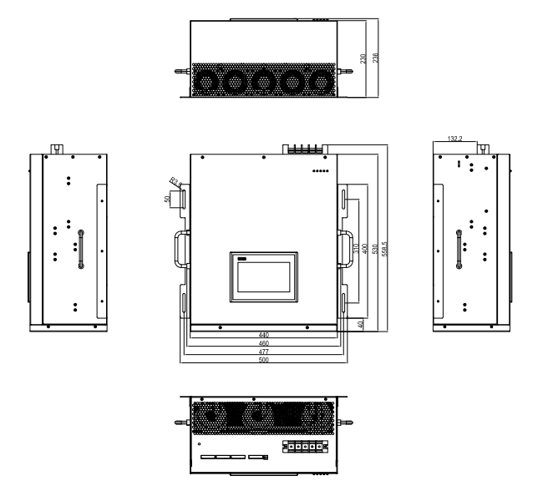

Figure 6-1 Overall Dimension Drawing (Unit: mm) of Wall mounted(50/75A)

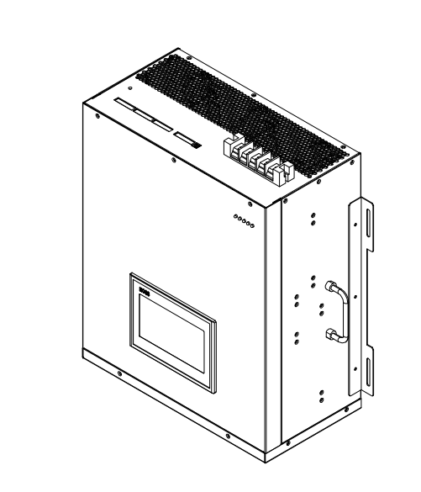

Figure 6-2 Overview

**Chapter VII Free landing Cabinet**

|  |  |
| --- | --- |
|  |  |

Figure 7-1 Active Power Filter Cabinet (100A~400A)

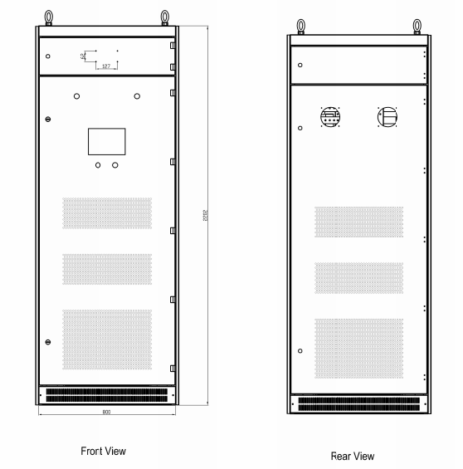

Figure 7-2 Overall Dimension Drawing (Unit: mm)

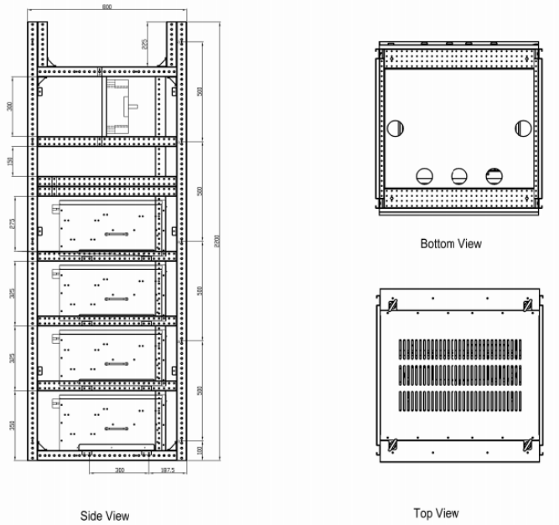

Figure 7-3 Side View,Top View and Bottom View (Unit: mm)

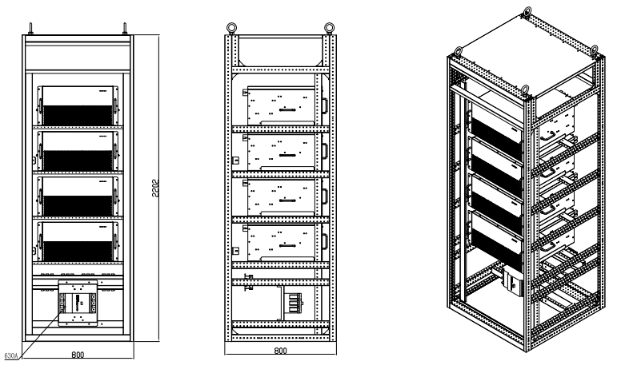

Figure 7-4 Bottom Entry (Unit: mm)

Remark:

1. .The cabinet capacity can be arbitrarily combined between 50A and 500A and the cabinet with larger capacity can be customized.
2. .The maximum capacity of cabinet (800x800x2200 mm) is 400A.
3. .The maximum capacity of cabinet (1000x1000x2200 mm) is 500A. (W * D * H)
4. .Protection grade of cabinet: IP30 (IP4X can be customized).