Subscribe to DeepL Pro to edit this document.
Visit www.DeepL.com/profor more information.



WMS Intelligent Storage System
Operation instruction book

October 2021

Catalog
I. Description of functional modules 4
1. 4
1.1 Permissions management 4
1.1.1 Roles 4
1.1.2 Personnel 5
1.2 Basic data 7
1.2.1 Material number 7
1.2.2 Suppliers 7
2. WMS 8
2.1 Warehouse establishment 8
2.1.1 Warehouse 8
2.1.2 Regions 8
2.1.3 Shelving 9
2.2 Label printing 11 2.2.1 Label printing 11
2.3 In-library operations 11
2.3.1 Material consolidation/splitting 11
2.3.2 Inventory sheets (PC) 12
2.3.3 Overdue materials 13
2.3.4 Stagnant materials 13
2.3.5 Electronic Shelf Inventory 14
2.4 Outbound 15
2.4.1 Outbound order import 15
2.4.2 Outfeed analysis 15
2.5 Statements 16
2.5.1 Inventory 16
2.5.2 Finding material 16
2.5.3 UPN Job History Query 17
2.5.4 Analytical results query 17
2.5.5 Online Material Inquiry 18
2.5.6 Goodbye task queries 18
2.5.7 Locked UPN Queries 19
2.5.8 Pre-Analysis Lock Library Query 19
2.5.9 Printing queries 20
2.5.10 UPN No Document Miscellaneous Receipt and Delivery Queries 20
2.5.11 Splitting records 21
3. Shelving services 21
3.1 Shelf configuration 21
3.2 Shelving Services 22
3.3 WMS Services 23

- Function Module Description
- Basic Data
1.1 Permission management
1.1.1 Role
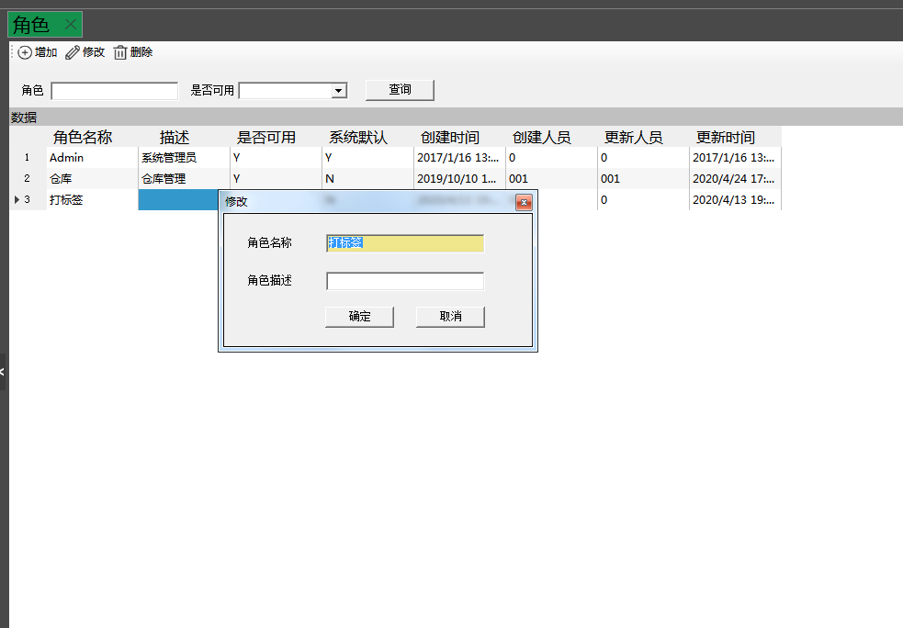
- Roles can be added, modified and deleted.
- Check a role and right click on the permission to add a function to the role. Just check it and save it.
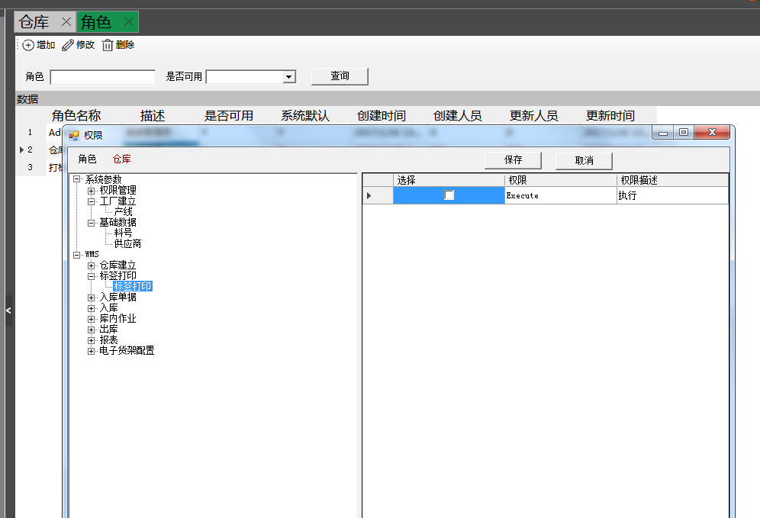

1.1.2 Personnel
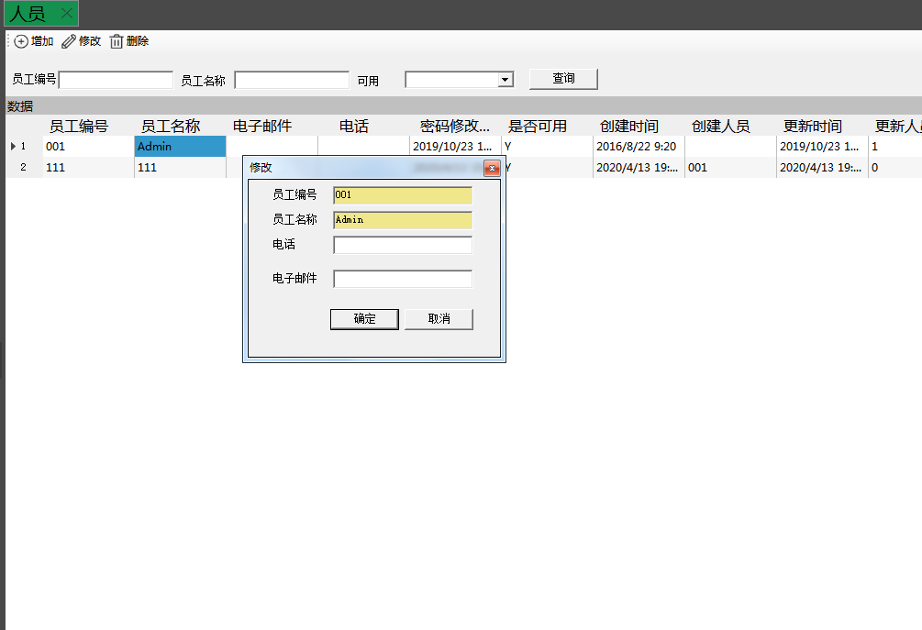
- People can be added, modified and deleted, and the password for new people is 123456.
- Personnel can select a role, select the role and click OK, the personnel has the functions under this role.
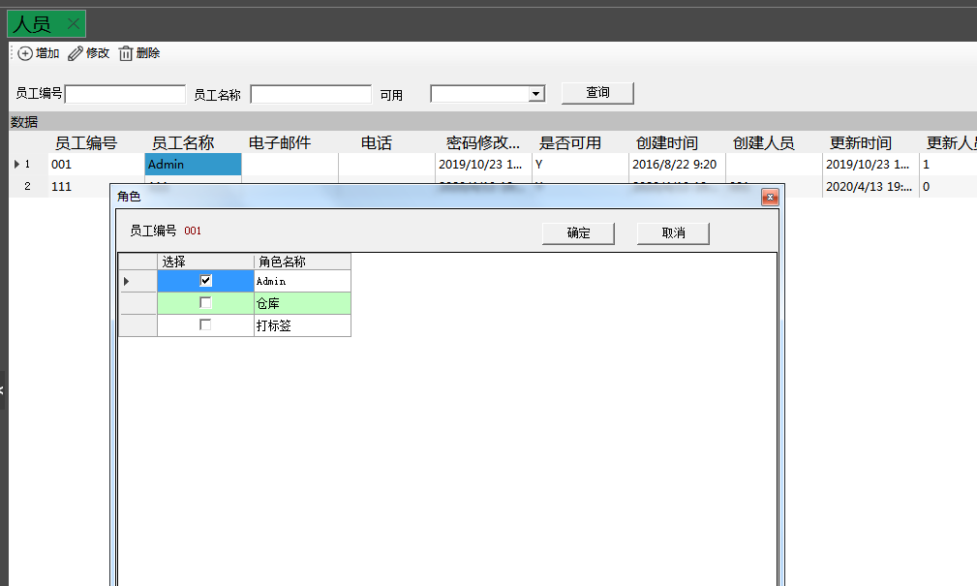
- You need to configure the inventory organization and right click on the configured warehouse to operate the shelves corresponding to this warehouse
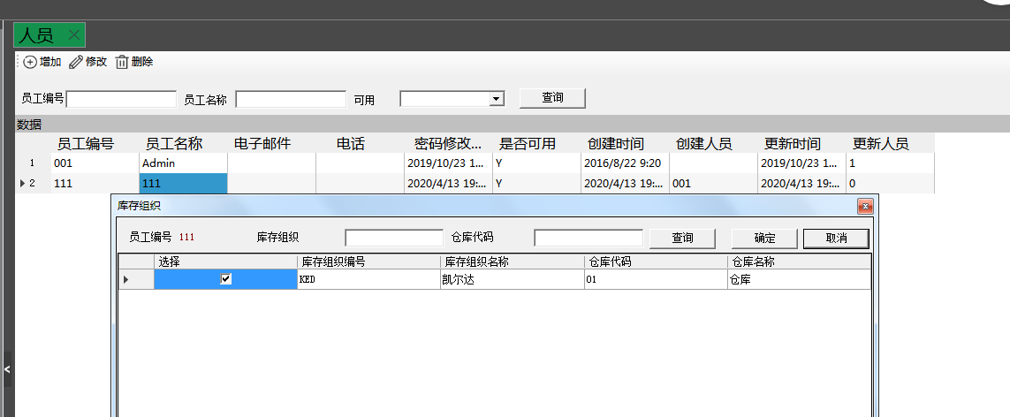
- Personnel can reset the password, the initial password 123456
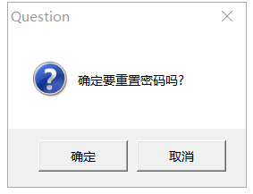

1.2 Basic data
1.2.1 Material number
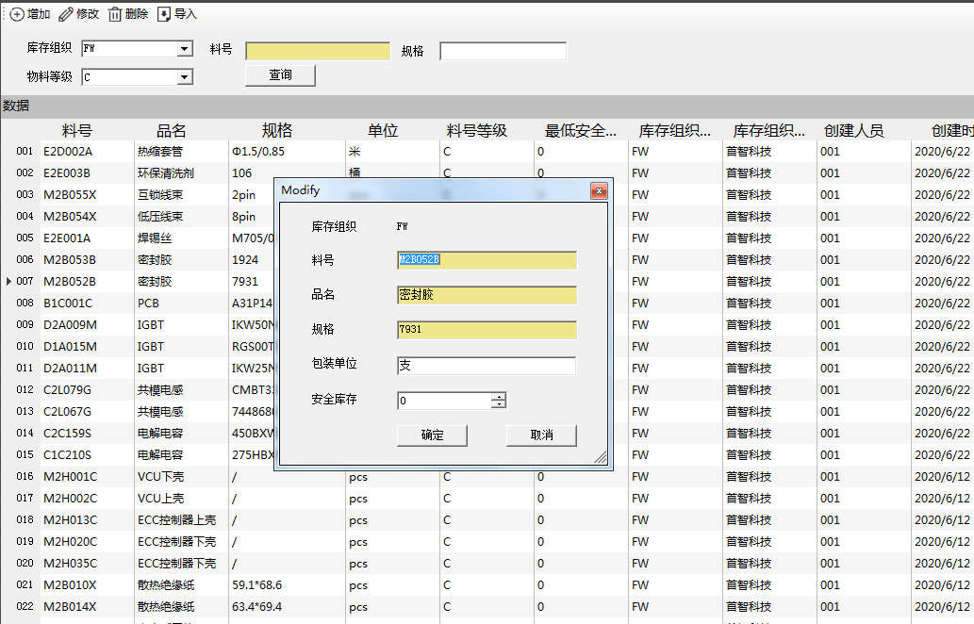
1. The role of the material number determines the incoming and outgoing material and printing, and must ensure that the data is correct. You can add, delete, and check individually. You can also batch import according to the template.
1.2.2 Suppliers
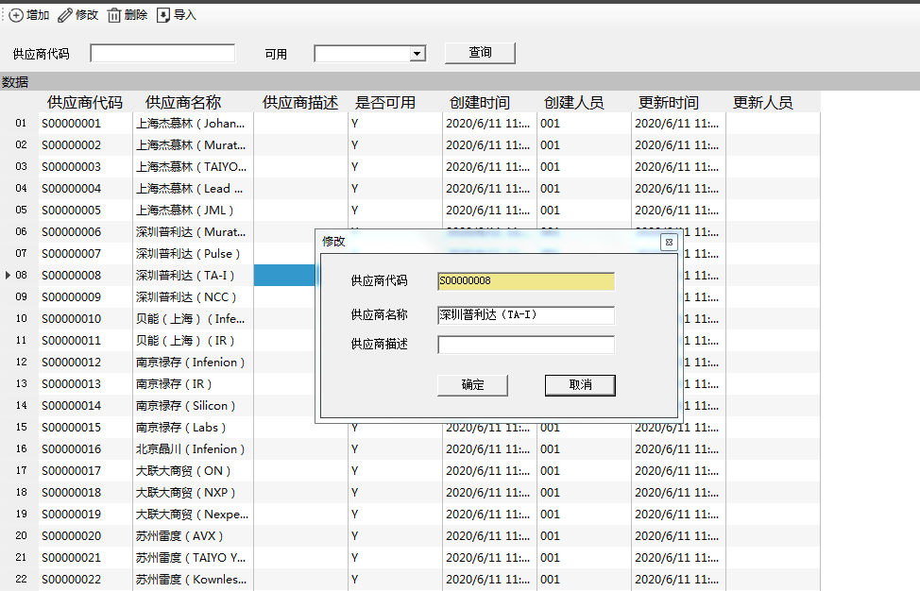
1. Maintain supplier information, which can be added, deleted, and checked. You can also import in bulk according to the template.
- WMS
2.1 Warehouse establishment
2.1.1 Warehouse
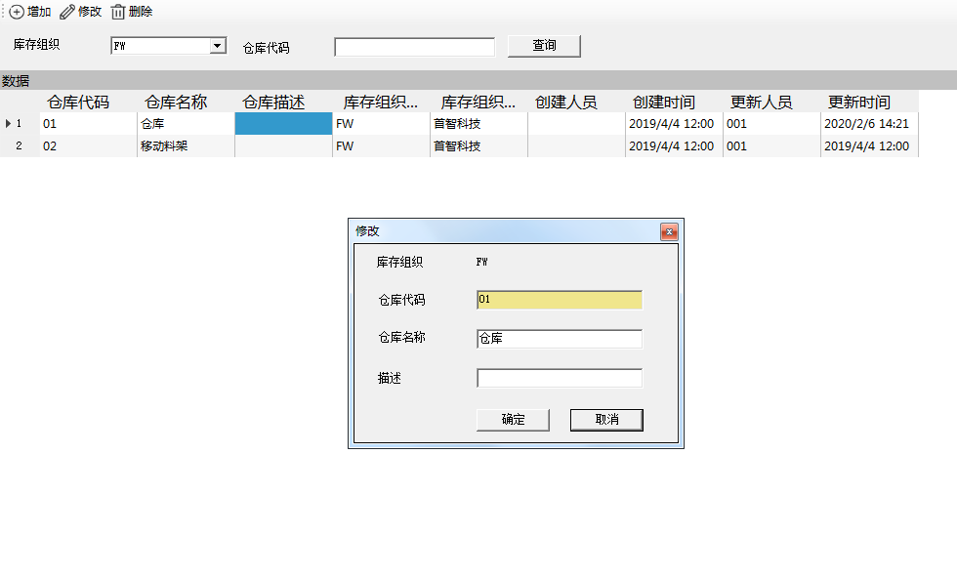
Warehouse management, including add, modify and delete.
2.1.2 Area
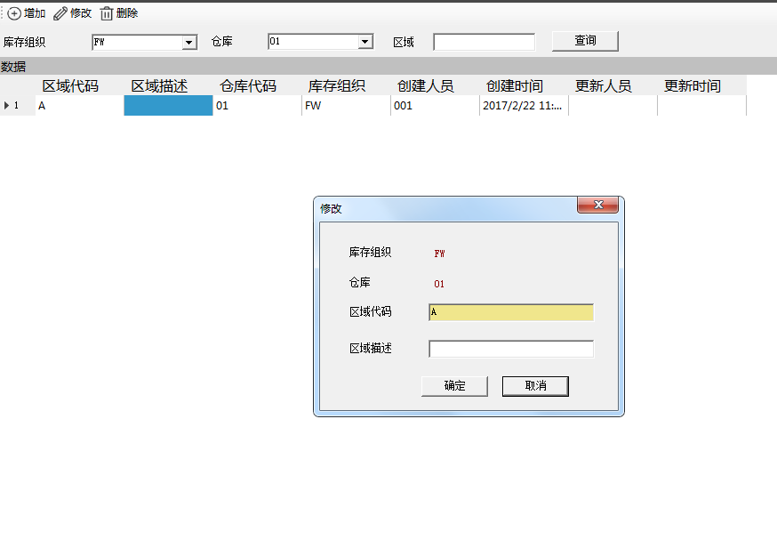
Area management, including add, modify and delete. (Not used yet)

2.1.3 Shelving
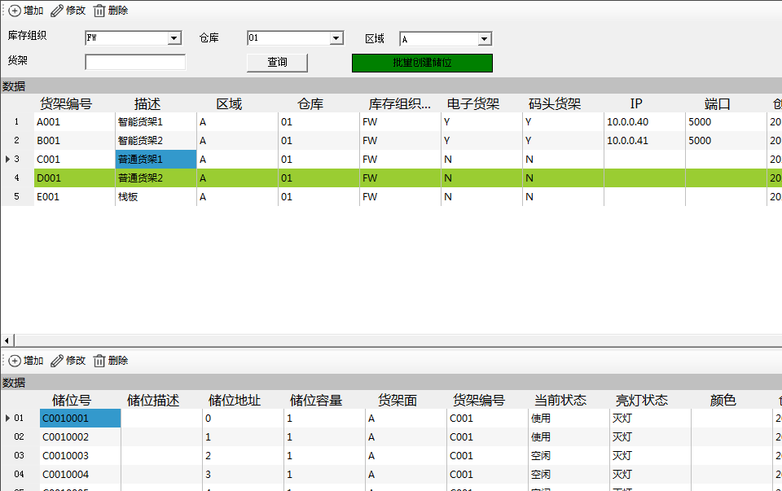
- Shelf information management, including add, modify and delete.
- Shelf information includes IP and port, keep the same configuration with the physical shelf, check the electronic shelf is a prerequisite for the light of the storage position
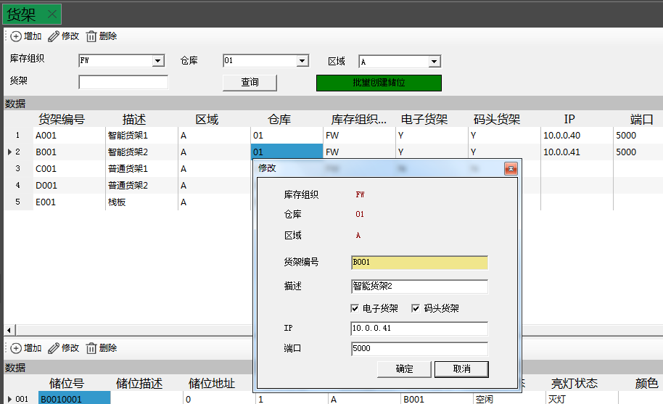
3. Batch create storage space: shelf surface 7 inch A side 700, B side 700, 13 inch A side 240, B side 240; storage capacity single storage space can store the number of trays, electronic shelf is a tray; prefix is the shelf number; start serial number 7 inch A side from 1, B side from 701, 13 inch A side from 1, B side from 241; expand the number of 7 inch is 700, 13 The number of unfolded 7 inches is 700, 13 inches is 240; the number of bits are 4 bits and the barcode on the physical shelf is the same. The storage position is A, B side separately unfolded, and then click OK.
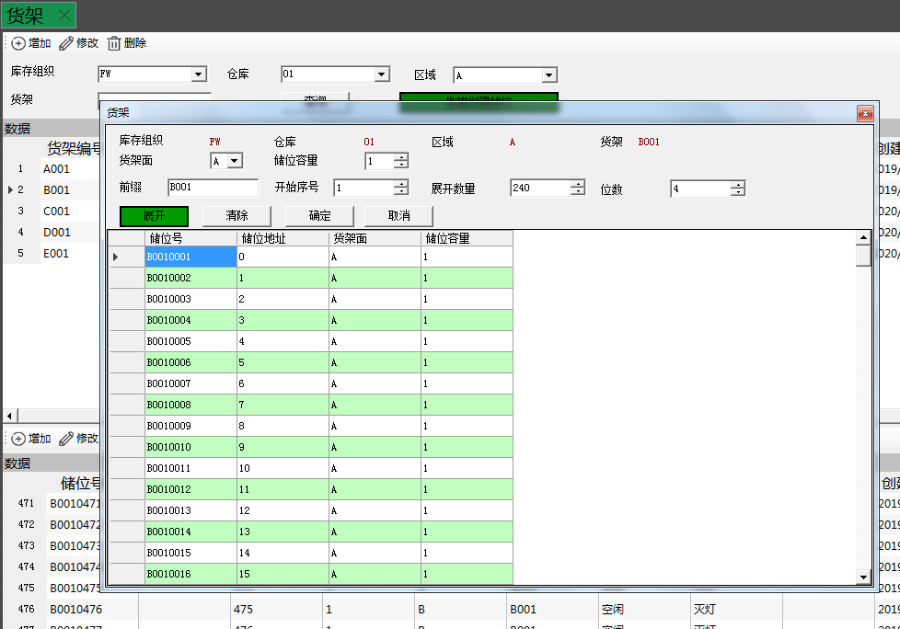
4、Single storage space can be added, modified and deleted
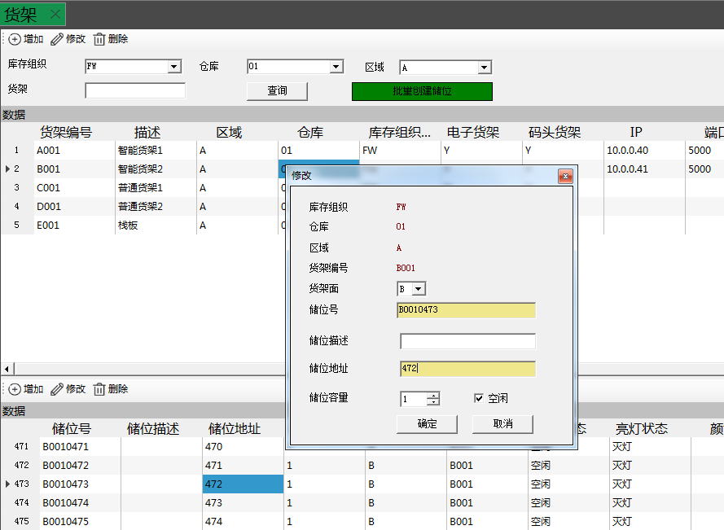

2.2 Label printing
2.2.1 Label printing
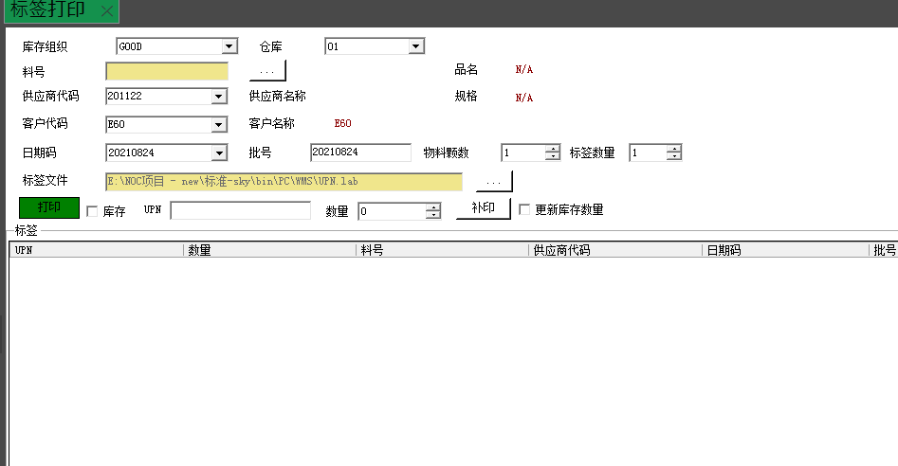

Select the material number to be printed and check the information. Select the number of sheets and quantity to be printed, click the Print button for single or batch printing, or you can input UPN and press the Enter button to make up the print, or you can change the quantity and click the Make Up button to make up the print operation.

2.3 Depot operations
2.3.1 Material consolidation/splitting
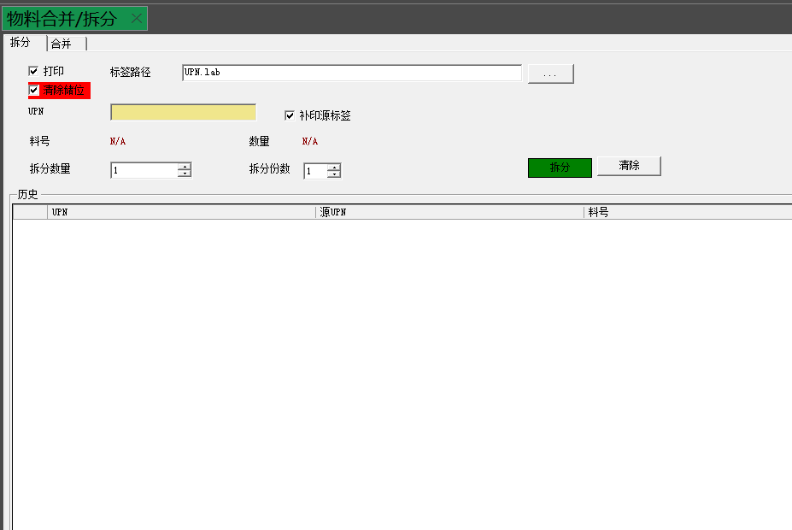
1. You can split or merge the materials inside the inventory as needed. Note the check box to make up the original label, whether to eliminate the storage space of the raw material tray, and the number of copies and trays split. (The number of split copies does not include the original label).

2.3.2 Inventory sheets (PC)
1. Inventory list: Inventory list can be added, modified and deleted. When the warehouse needs to do inventory, you can first create an inventory list, inventory type including shelves, material number and warehouse.
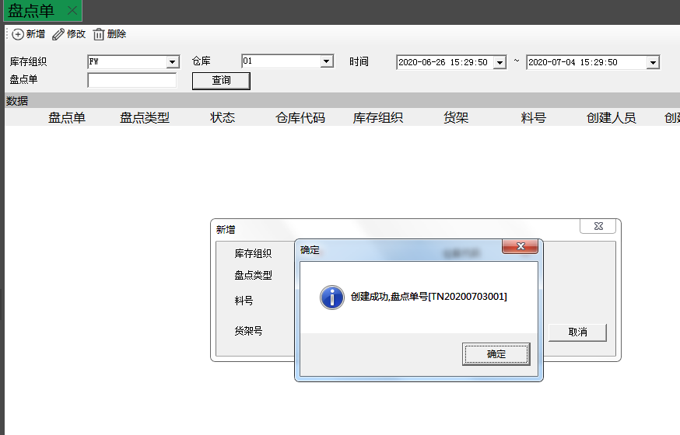
2. After the inventory list is created, select the inventory list on the PDA and then scan the material tray to complete the inventory, after the inventory is finished, you can select the inventory list right click to have inventory details, inventory details, discrepancy details and other reports.
3. You need to right click to close the inventory sheet manually after the inventory is completed.
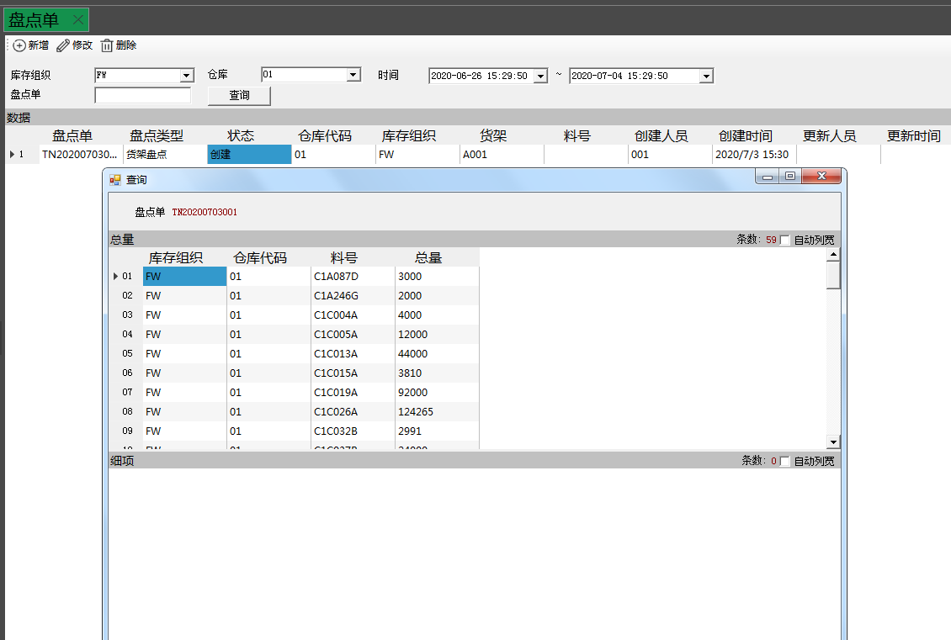
2.3.3 Overdue materials
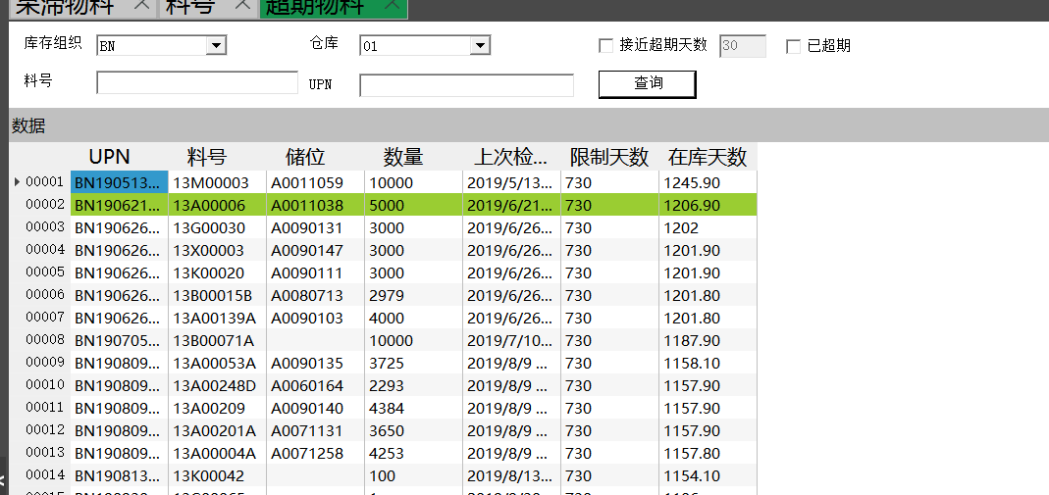
Enter the material number and upn to check the information of a material separately.
After checking the option that has expired, all the queries are already overdue.
Ha can search for options close to the number of days overdue check the box and then you can manually enter how many days

2.3.4 Stagnant materials
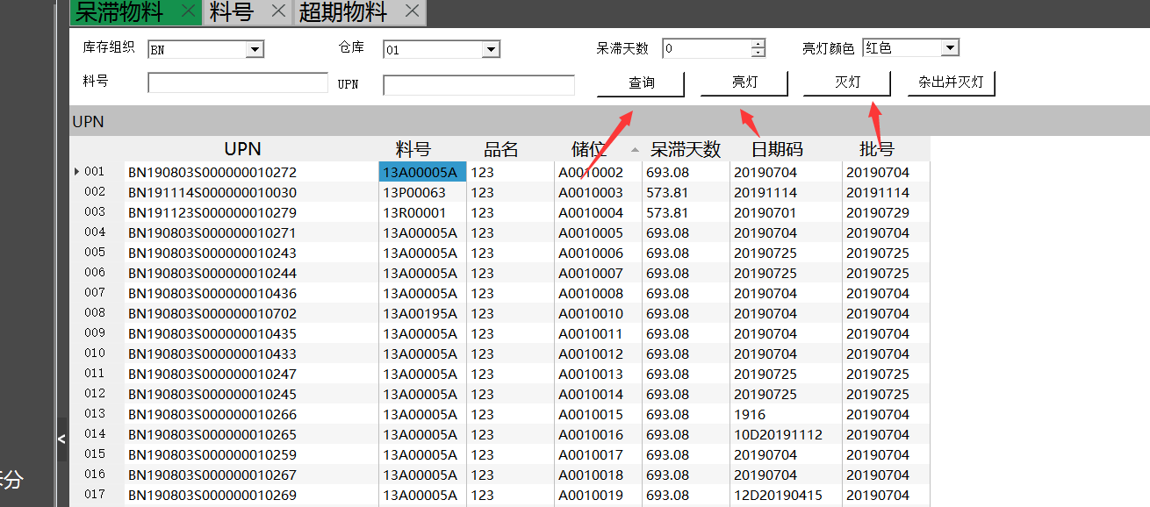First click the query and then query to the single upn or query to a material number of all the trays click the light can be, no query to the data is not lighted also can choose the color of the light

2.3.5 Electronic shelf inventory
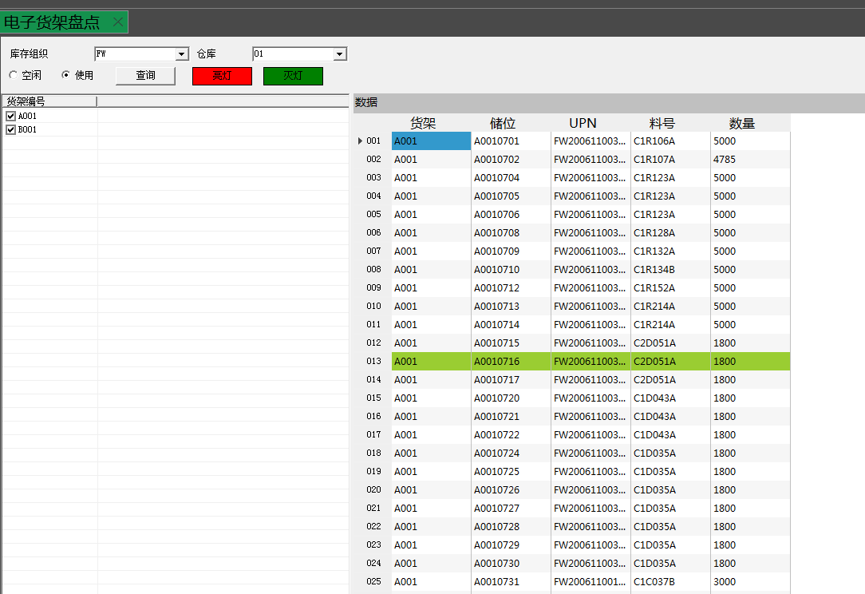
Electronic shelf inventory: check the storage position, select idle or use click query can find out the corresponding storage information, click on the light can check whether the materials on the shelf and storage position are bound correctly. Query idle light if the lighted position has a material tray, then this material tray is abnormal, query use light if the lighted position does not have a material tray, then this storage position is abnormal.

2.4 Out of storage
2.4.1 Outbound order import
According to the template import transfer order data, you can also query the transfer order information saved in the wms system.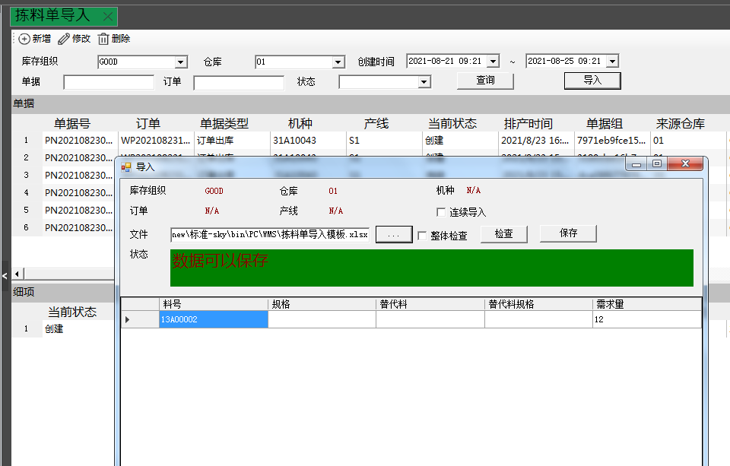
2.4.2 Outfeed analysis
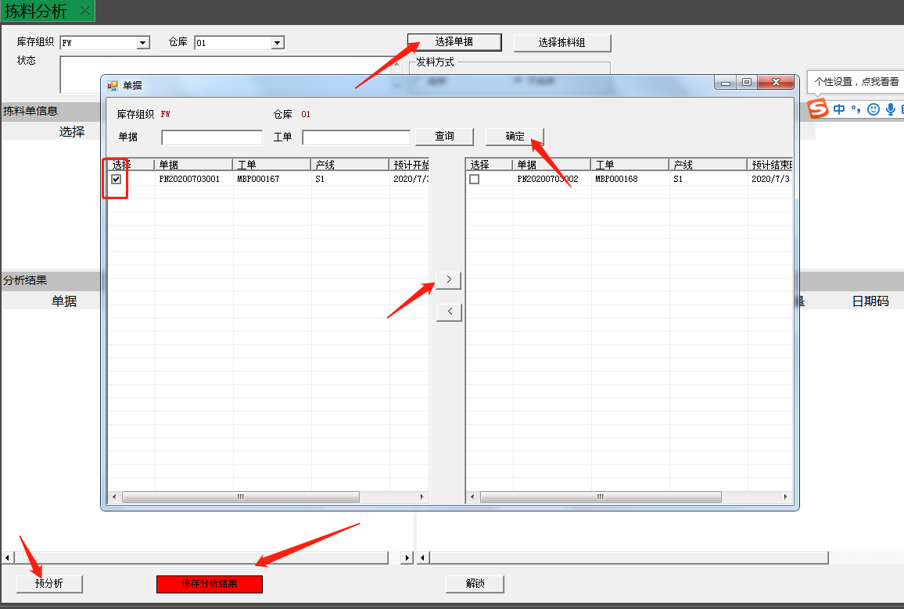
Select the transfer document, check it and move it to the right side (you can combine multiple transfer orders for issuing materials). OK, then click on Pre-Analysis to see the out-of-stock status, and click on the red Save Analysis Results button once you have met the requirements you have in mind.

2.5 Statements
2.5.1 Inventory
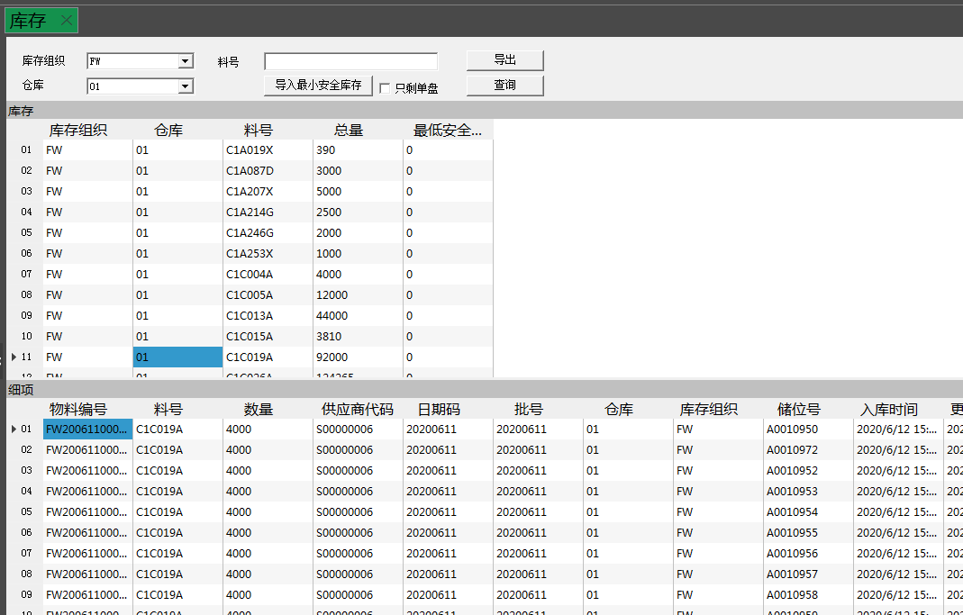
You can view the inventory by warehouse and material number, and select the material number with the mouse to view the detailed items of this material number, accurate to each UPN (incoming quantity, current quantity, incoming date, batch number, current storage position, supplier) and other information.
2.5.2 Finding material
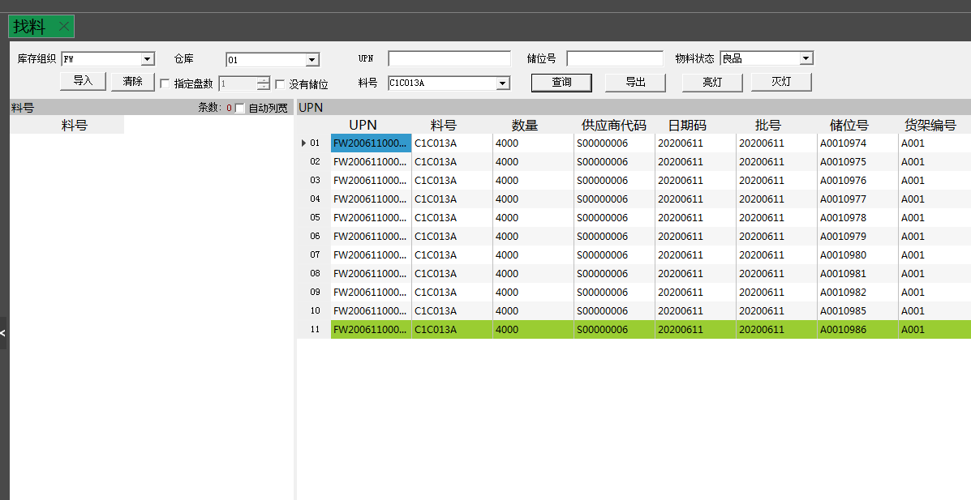
According to the material number, UPN, storage position and material status and other conditions to query the physical inventory, you can also batch import the material number and quantity to query the physical inventory, and light up the physical location. Check no storage position to query the inventory of unbound storage position, check the specified number of trays and modify the quantity, each material number can query less than or equal to the specified number of trays, sorted by DATE_CODE and print time from smallest to largest.

2.5.3 UPN operation history
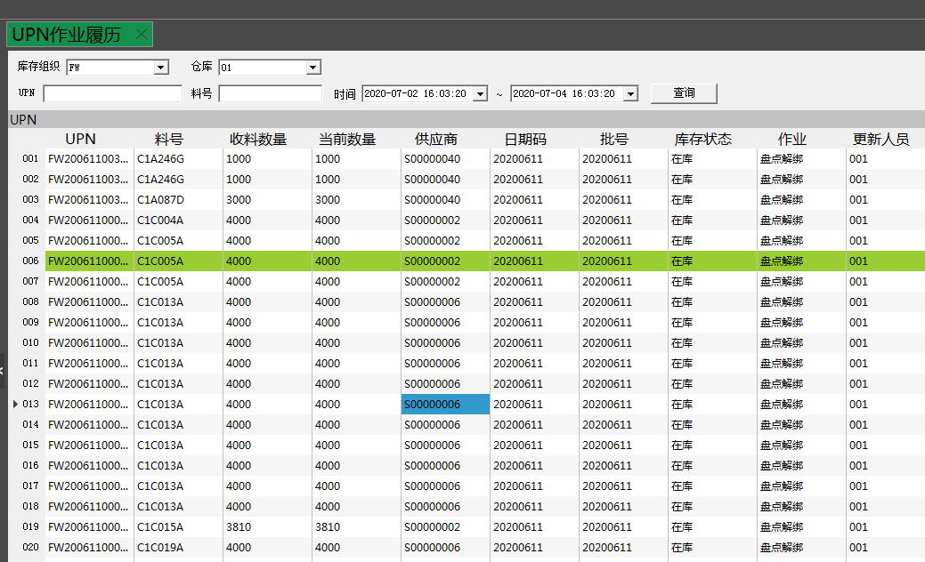
The history of all operations from inbound to outbound use of a pallet can be queried by material number, UPN, lot number, notes and time.

2.5.4 Analysis result query
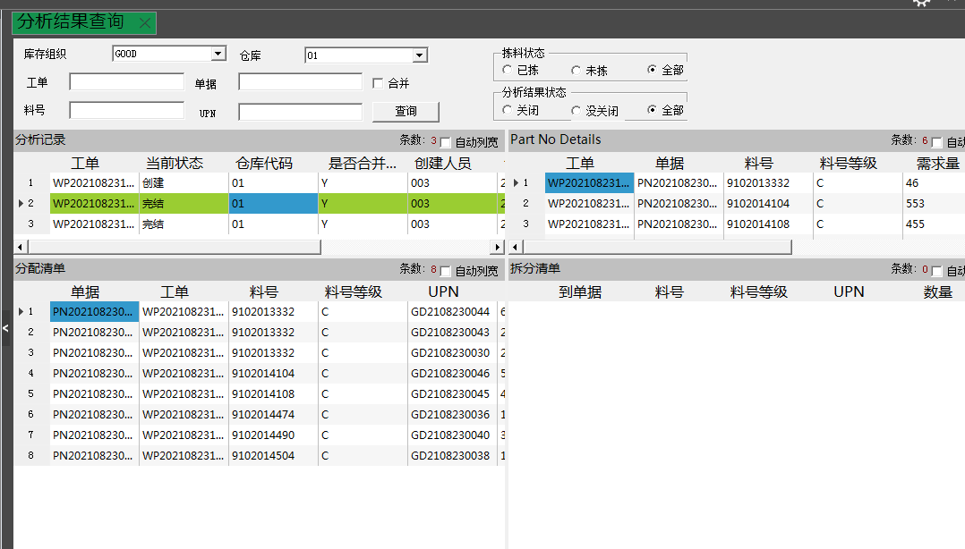
Analysis result query, you can query the analysis result by work order, document, material number, UPN, picking state and analysis result state, right click to close and delete the document by selecting the analysis detail.

2.5.5 Online material inquiry
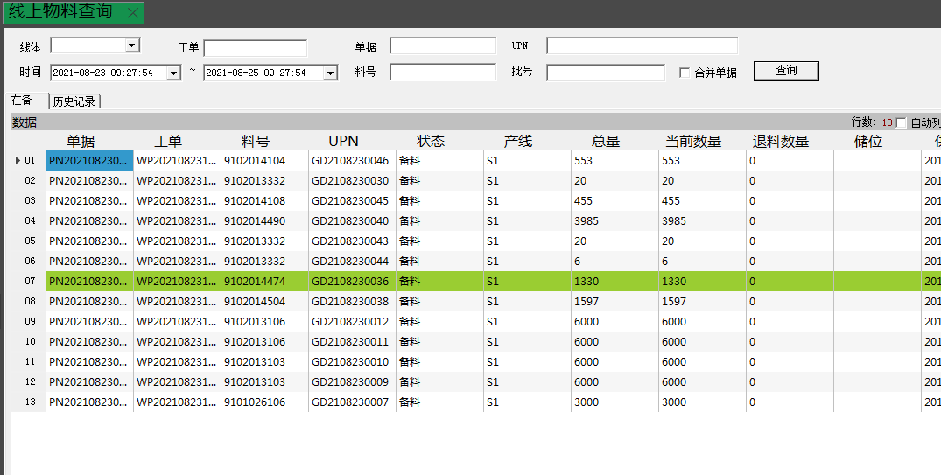
On-line material query, (this material is PDA picking material, issued material, can be re-entered by way of return material) can query on-line material by work order, document number, and time and other conditions.

2.5.6 In-picking task queries
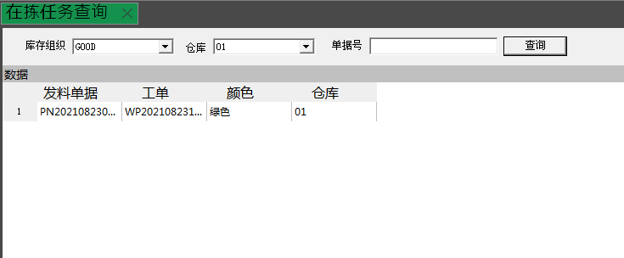
Check the current picking task, and right click on the selected task to delete the picking task.

2.5.7 Locked UPN Queries
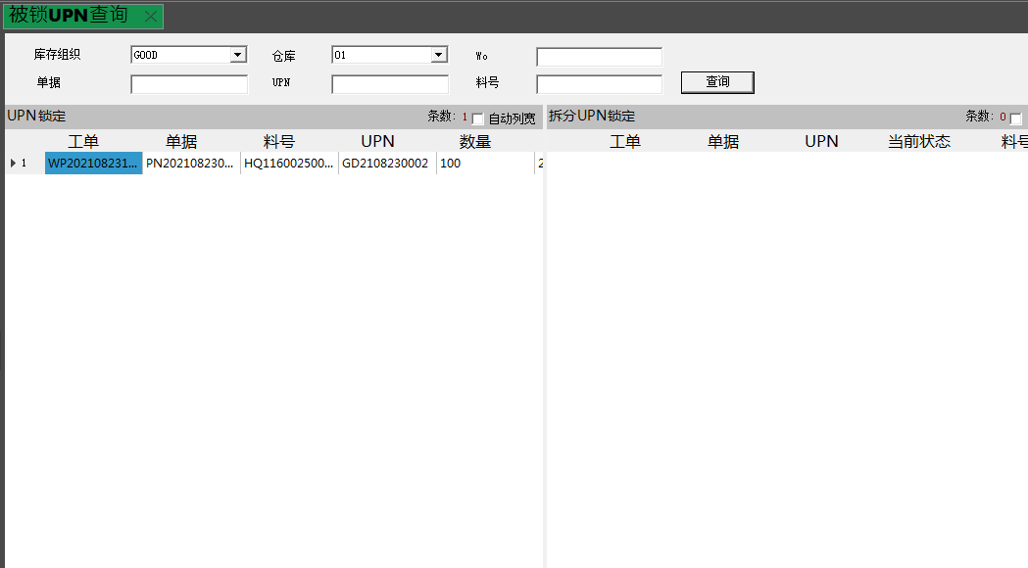
Query and analyze the locked UPNs and the UPNs for creating picking tasks.

2.5.8 Pre-analysis lock library query
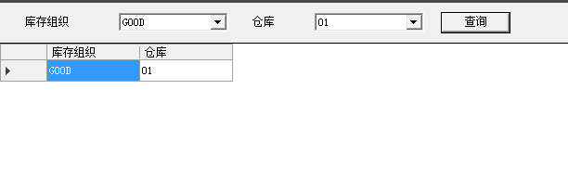
Query the pre-analysis results by warehouse, (in the picking analysis, if this warehouse is locked prompt, you need to go here, right click to unlock) select the query record right click to unlock, the warehouse inventory can be used.

2.5.9 Printing queries
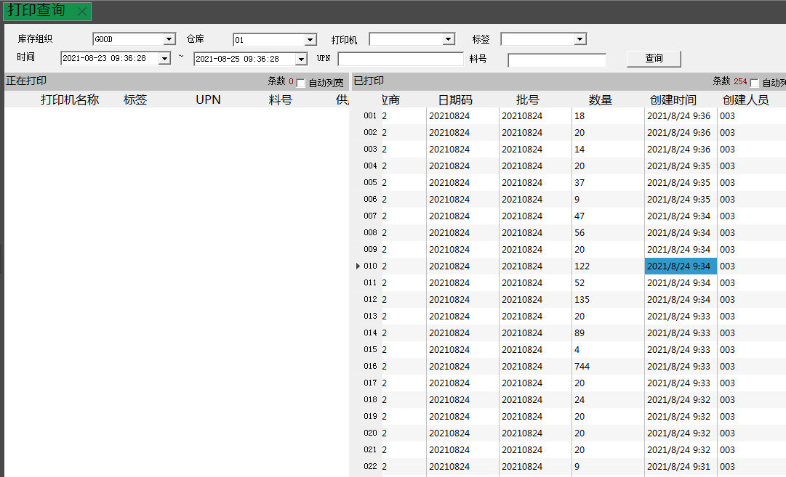
Query the history printed records.

2.5.10 No documentary miscellaneous receipt and dispatch queries
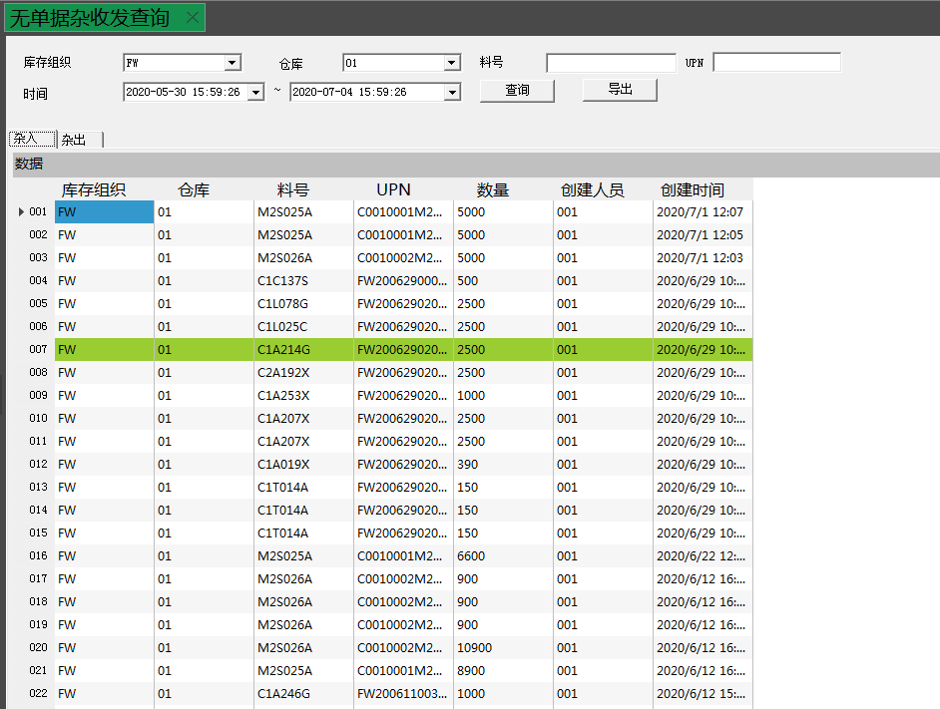
Search miscellaneous receipt and issue records by material number, unique code, time and other conditions.
2.5.11 Split record query
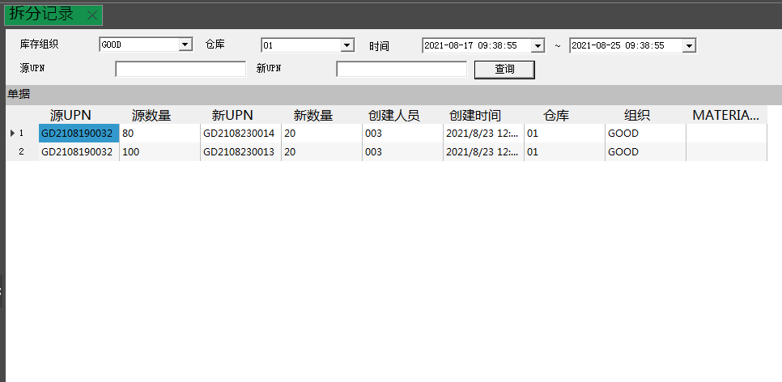
Query the records of all split materials.

- Racking Service
3.1 Shelf configuration
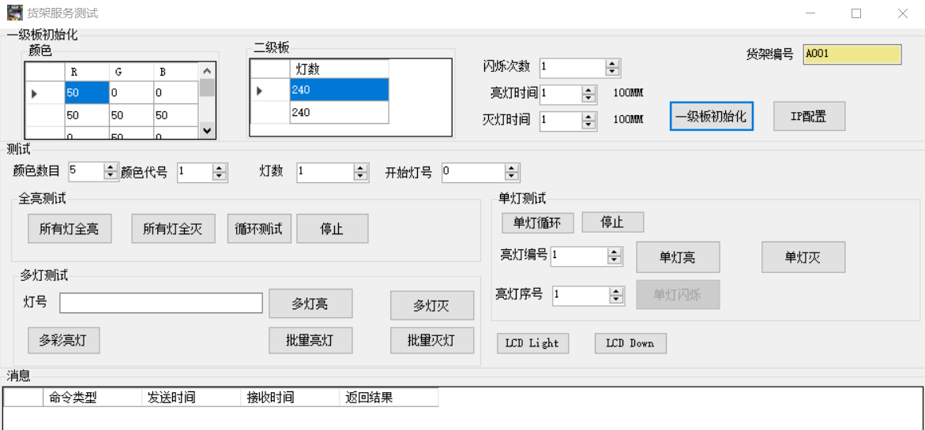
- Colors: R red, G green, B blue, RGB different values can be configured with different colors and brightness, right click can add, modify and delete colors. The first line is serial number 1, the second line is serial number 2 and so on.
- Secondary board: the number of configuration lights, 7 inch is 700 and 700, 13 inch is 240 and 240. right click can add, modify and delete.
- IP configuration, PC and electronic shelf through the device connection can be selected COM port, click open, enter the need to configure the IP, port default 5000, gateway and MAC (each shelf MAC to be set differently), mode default wired (new), click on the configuration to send the information to be configured, the command has received information means that the configuration is successful, otherwise it will fail.
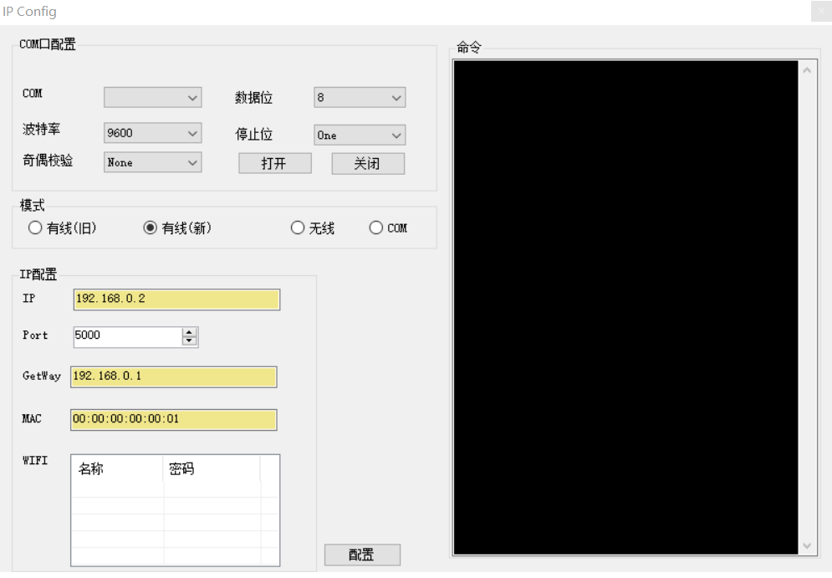
- First-level board initialization: When the IP configuration is successful, enter the shelf number, the color and the number of lights to complete the input, click the first-level board initialization to complete the configuration. (The first configuration is not used without special circumstances)
- Other function is to test whether the bright lights of the storage position are normal after the IP configuration is completed. (Before testing, you need to open the shelf service, and the IP in the file below must be set to the IP corresponding to the shelf service computer)
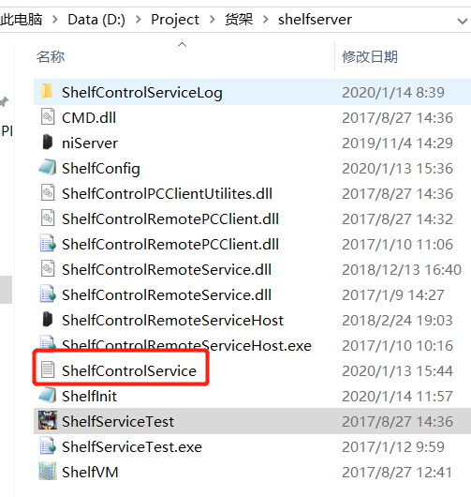
3.2 Shelf service
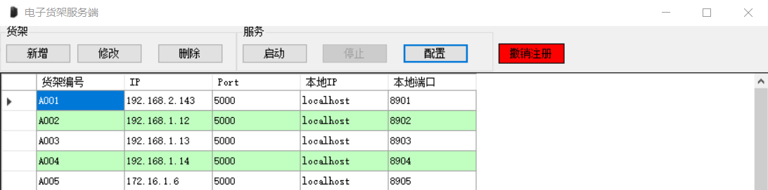
- The shelf service needs to be opened by right-clicking as administrator.
- You can add, modify and delete the IP and Port of the shelf number configuration. localIP defaults to localhost, and local ports are incremented in order.
- Click Start and the service starts listening to the electronic shelf.
- Revoke registration (don't click), you will need a registration code to use it after revocation.

3.3 WMS Services
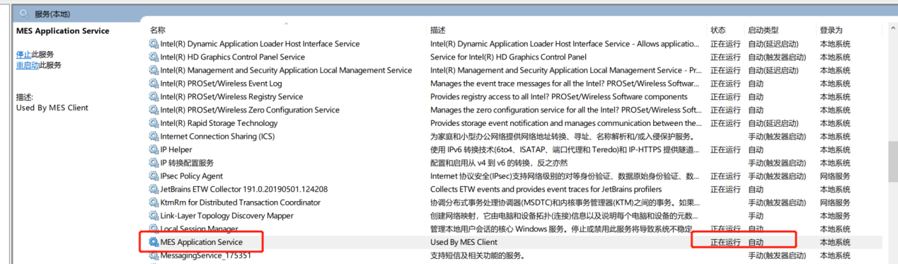
The wms service is deployed inside the windows service with the name MES Application Service, if the MES Client client cannot connect to the service, please check the status of the service to see if it is running.

