Kali Lighting Quotation Sheet

Date： Product：Recessed Emergency Light Model：
Supplier: Foshan Kaili Lighting Technology Co., Ltd. | Buyer:
Add: No.3 building, Zhifu Park Industrial Town, Shunde, Foshan city; Guangdong Province, China (528300) | Add：
Contact：Steward | Contact：
Mobile: 86 180 227 99159 | Mobile:
E-mail: sales@kl-international.com | E-mail：

Light Box Parameter
No. | Item | Parameter |  | Remark
1 | * Emergency Output | ________W
2 | Light Box Structure | Twin-Spotlight
3 | Installation | Recessed Mounted
4 | Size (Box with Light) | L : |  | Use mm as unit  If no specific size, we use general size.
4 | Size (Box with Light) | W : |  | Use mm as unit  If no specific size, we use general size.
4 | Size (Box with Light) | H : |  | Use mm as unit  If no specific size, we use general size.
5 | Size (Front Plate) | L : |  | Use mm as unit
5 | Size (Front Plate) | W : |  | Use mm as unit
6 | Color Temperature |  |  | 4000K / 6500K
Battery Parameter
7 | * Main Voltage |  | ________V
8 | * Discharge Duration |  | ________H
9 | * Charging Time |  | ________H
10 | Battery |  | ☐Ni-Cd  ☐Ni-Mh  ☐Lithium Iron Phosphate
11 | Comply With EMC Standards |  | ☐Yes  ☐No

Other
12 | Indicator Light | ☐Mains  ☐Charging  ☐Fault | - Mains: Power on status is red.  - Charging: Charging status is red, fully charged is green.  - Fault: When a fault occurs, it turns yellow.
13 | Button | ☐Text | 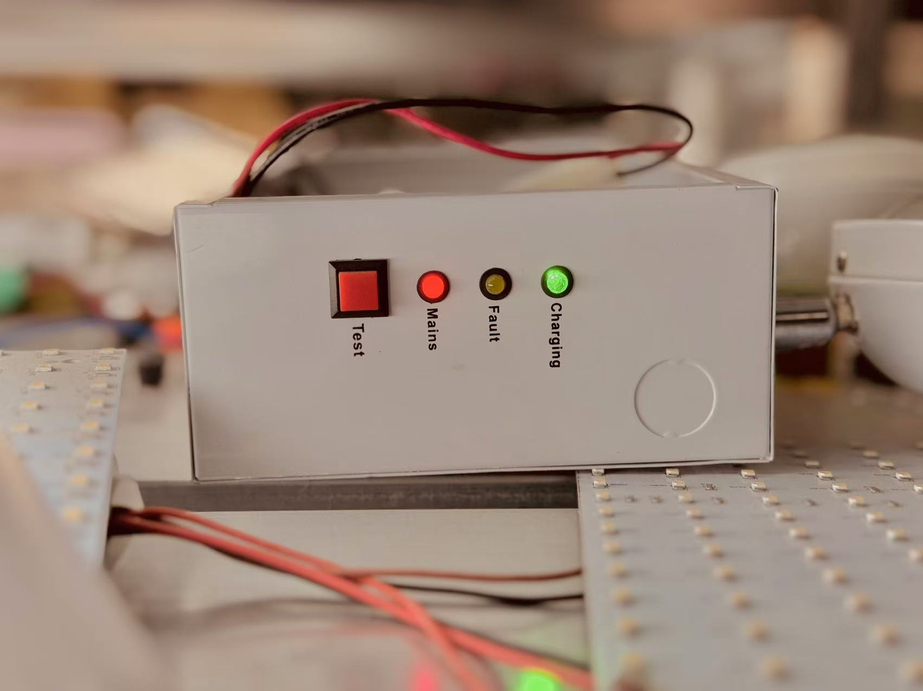
Quantity
14 | Quantity
Quotation
15 | Price
Product Reference
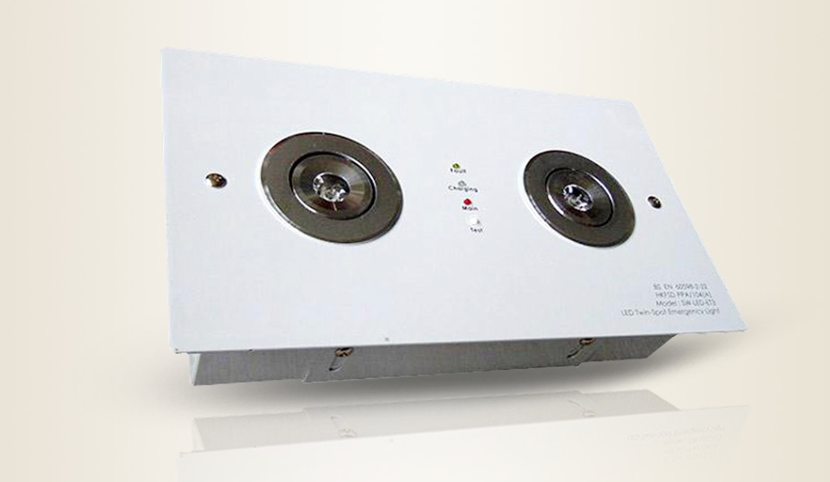
Remark
- Asterisks are required.
- After the details are confirmed, we will provide a quotation reply as soon as possible.
- Process: Product Details → Sample Confirm → Order Confirm → Payment → Production
- For all products, product samples will be made first, and then the samples will be sent to customers. production will start after order confirmed.
- The time required for production depends on factors such as product quantity, model, etc.

